4-1: Determine (approximately) the internal moments at A, B and G caused by the vertical loading.

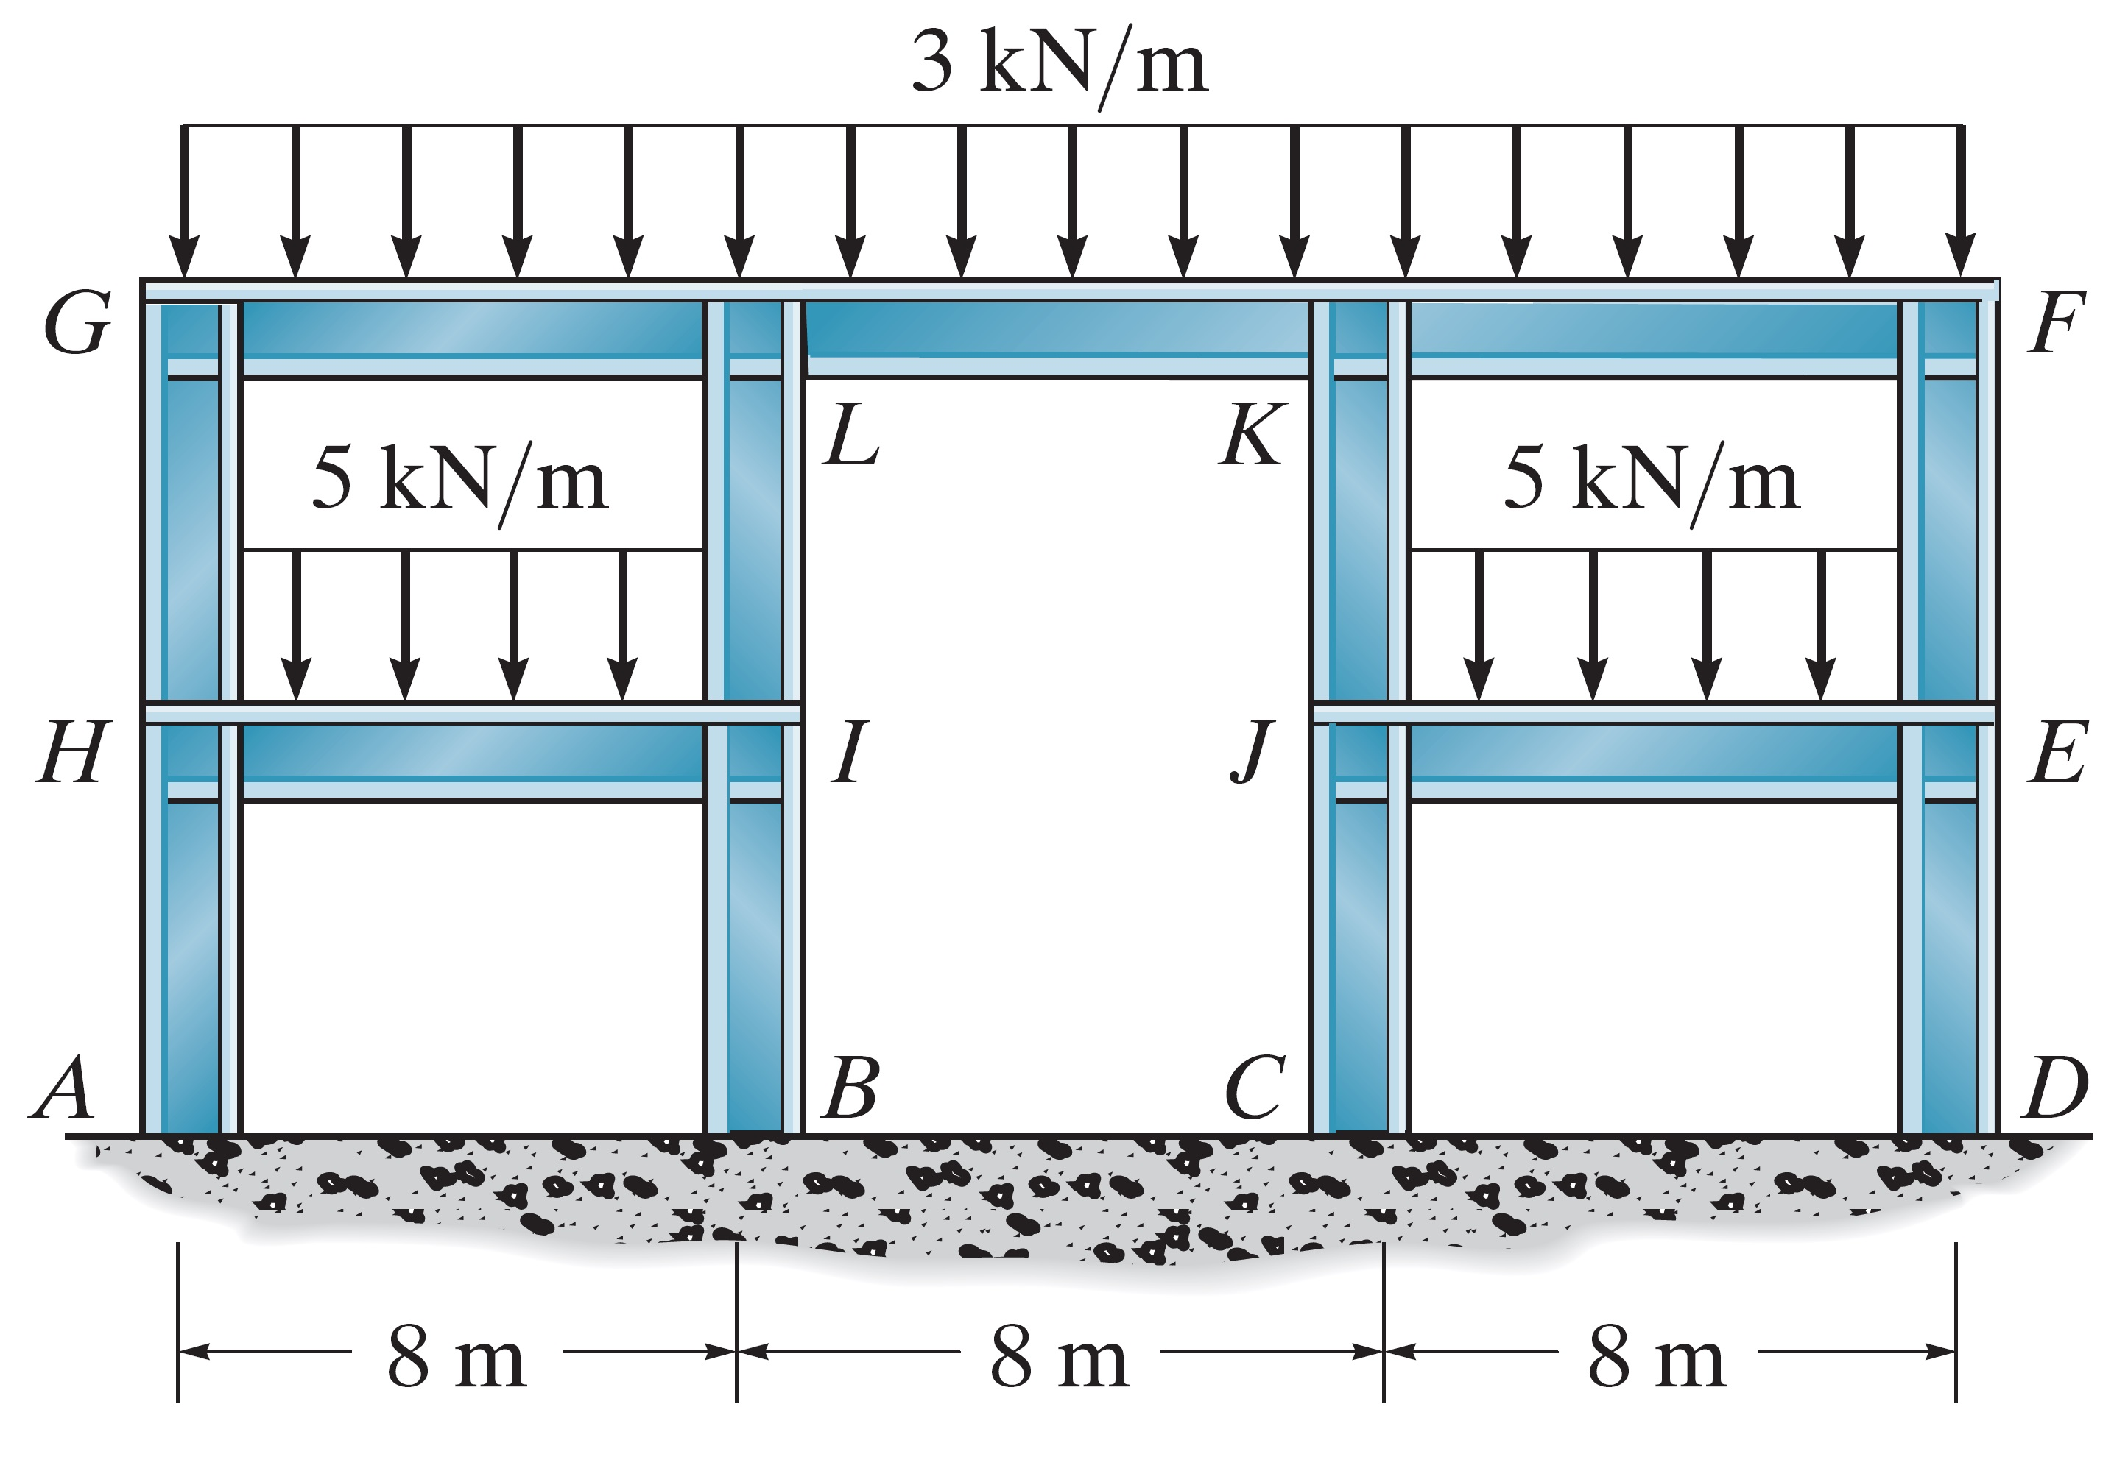

4-2: Determine (approximately) the reactions at supports A,B,C, and D by using both methods of portal and cantilever. All columns have the same cross-sectional area.

