4-1: Using the method of joints, calculate the force in each member of the truss shown. State whether each member is in tension or compression.

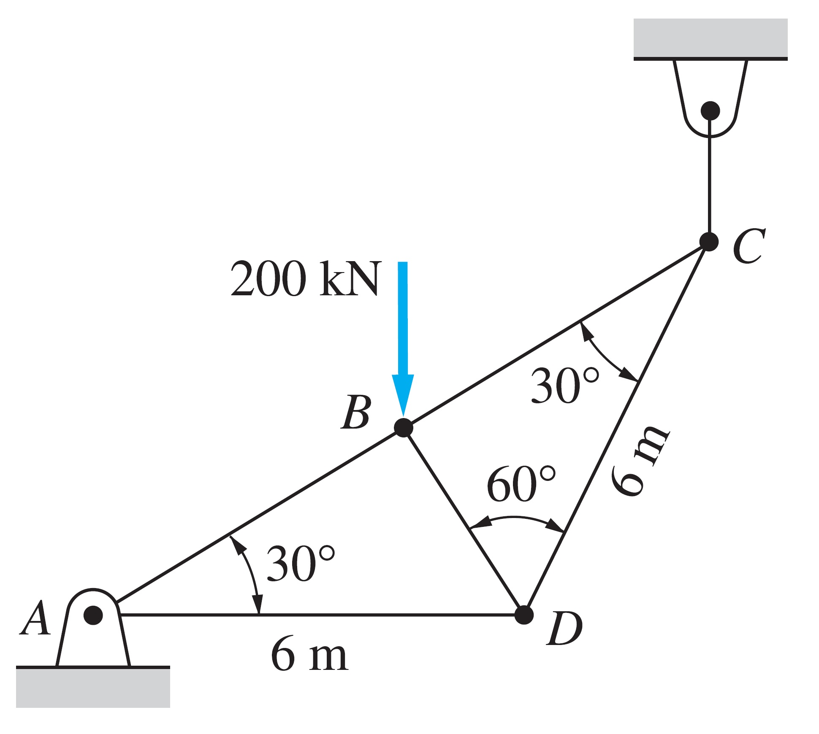

4-2: Determine the greatest load P that can be applied to the truss so that none of the members are subjected to a force exceeding either 2 kN in tension or 1.5 kN in compression.

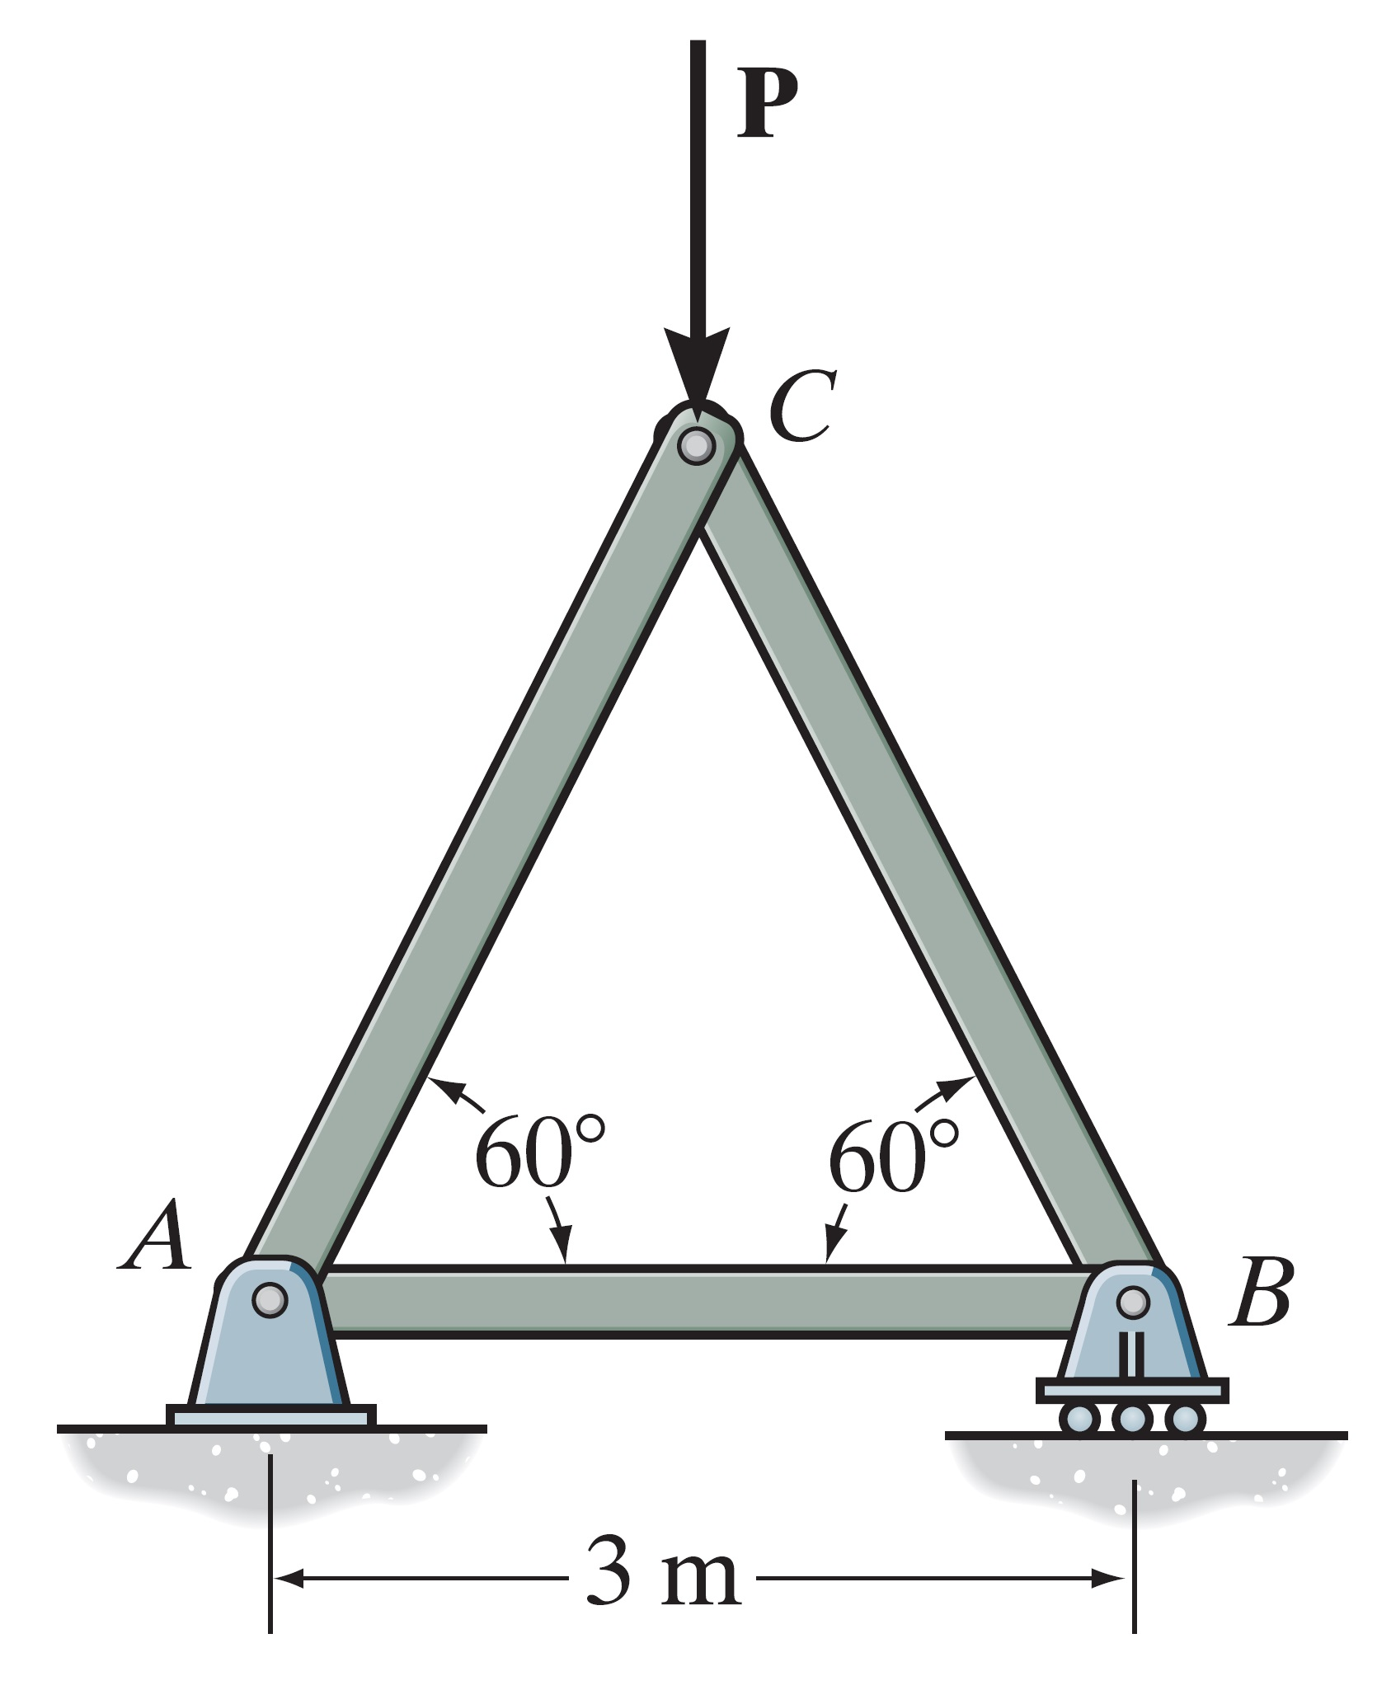
4-3: Identify the zero-force members in the truss.

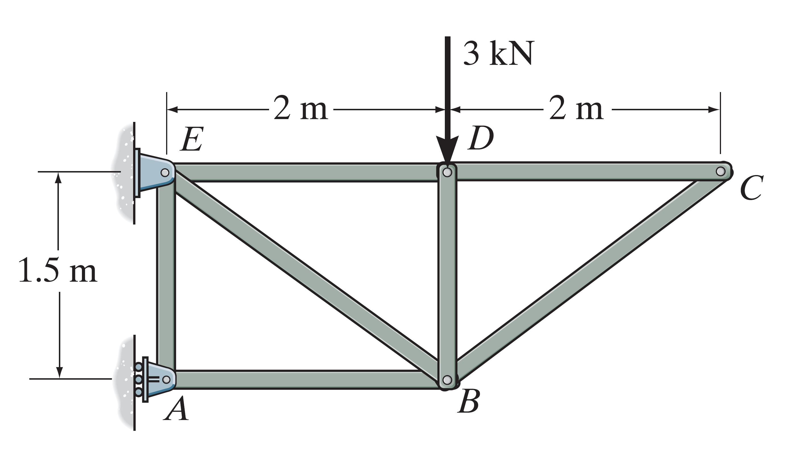

4-4: (a) Show that all diagonal members of the truss carry the same force, and find the magnitude of this force. (Using the method of section)

(b): Determine the forces in members FG and AB in terms of P. (Using the method of section)

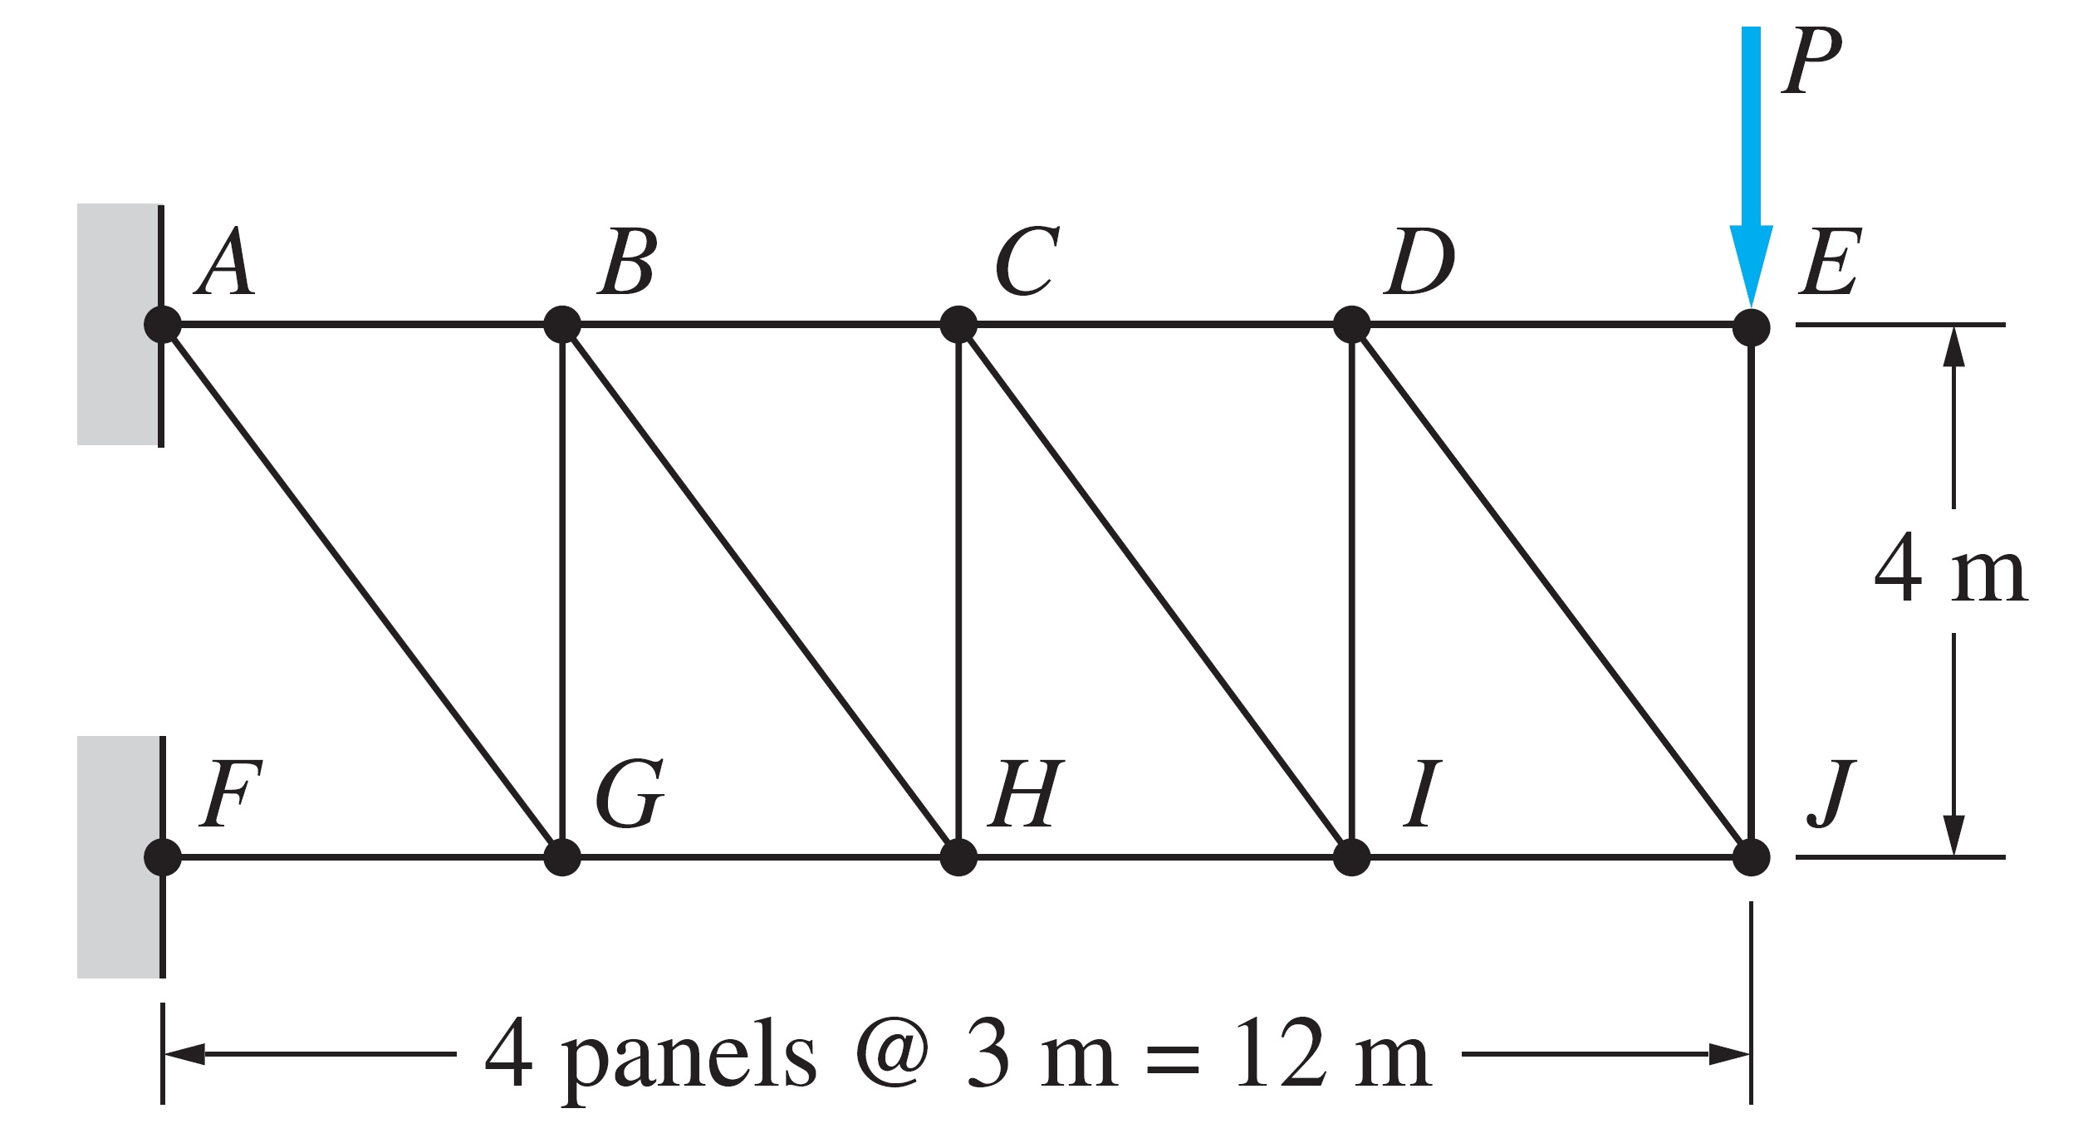
5-5: Determine the angle θ so that maximizes the tensile force in member BC and calculate the maximum value of this force. (Using the method of section)

