7-1: By integration, determine the moments of inertia about the x- and y-axes for the region shown.
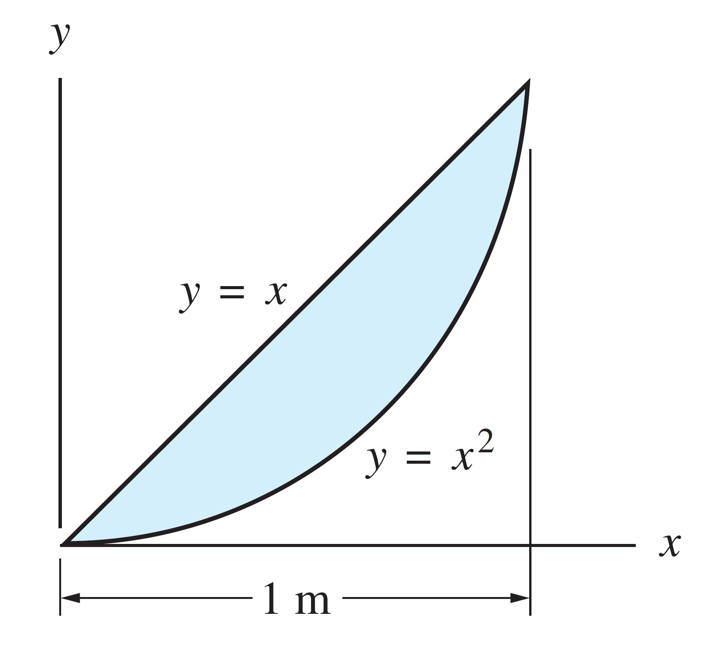
7-2: Using integration, compute the polar moment of inertia about point O for the circular sector.
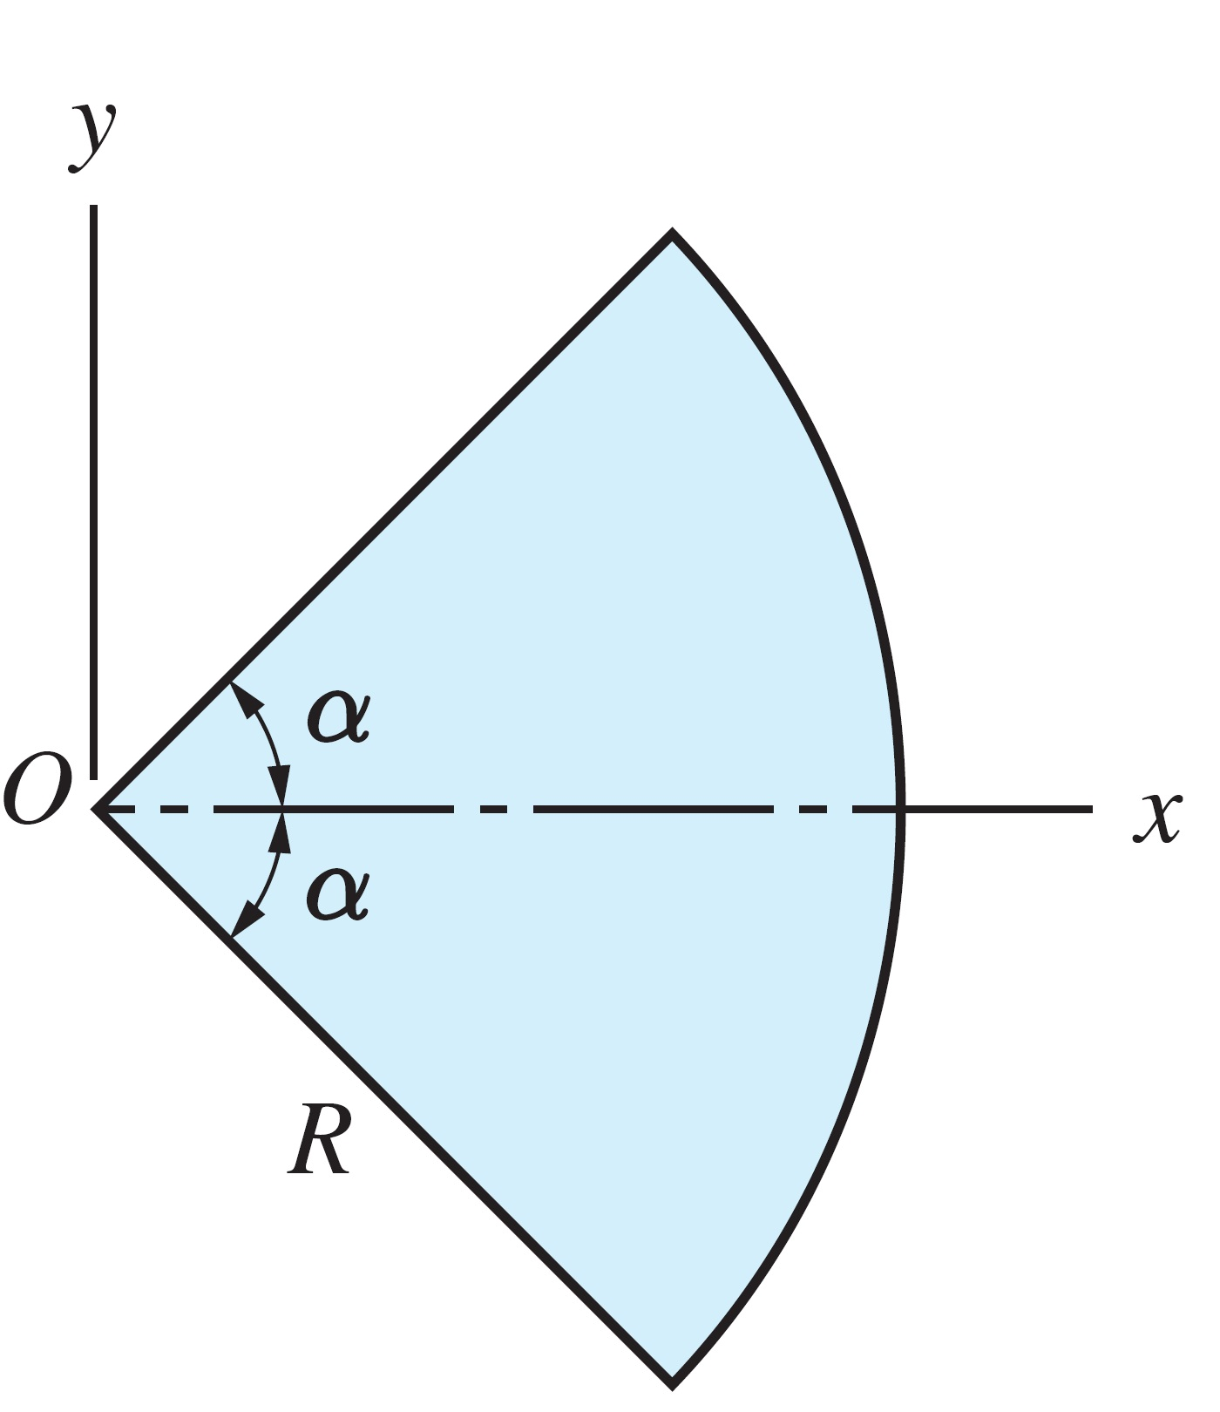

7-3: For the areas shown, calculate the radius of gyration about the x- and y-axes.

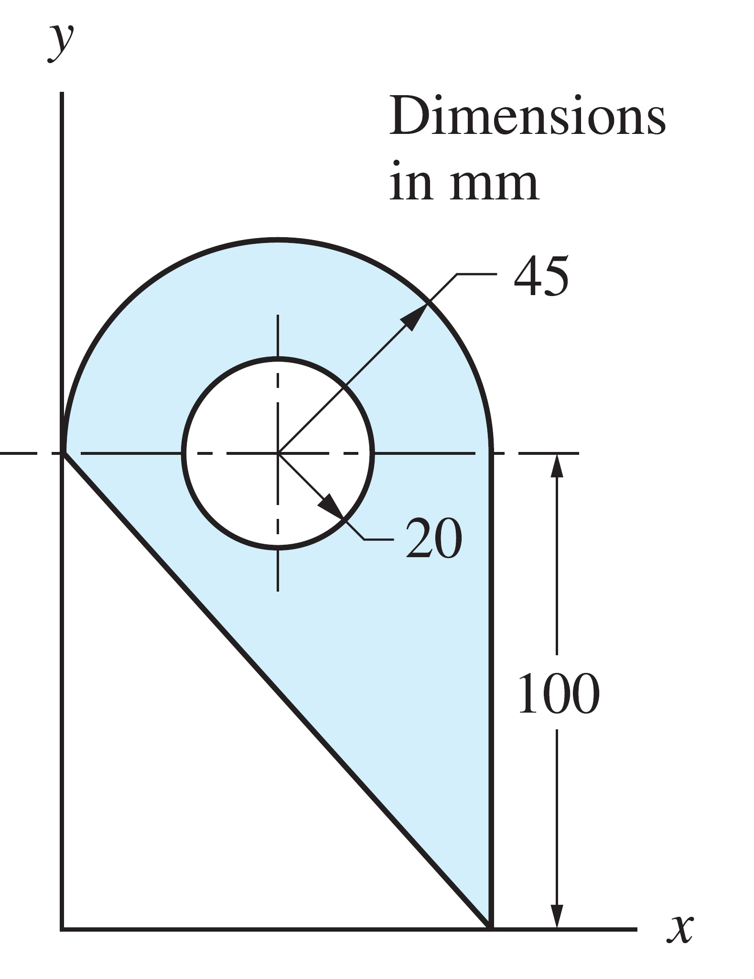
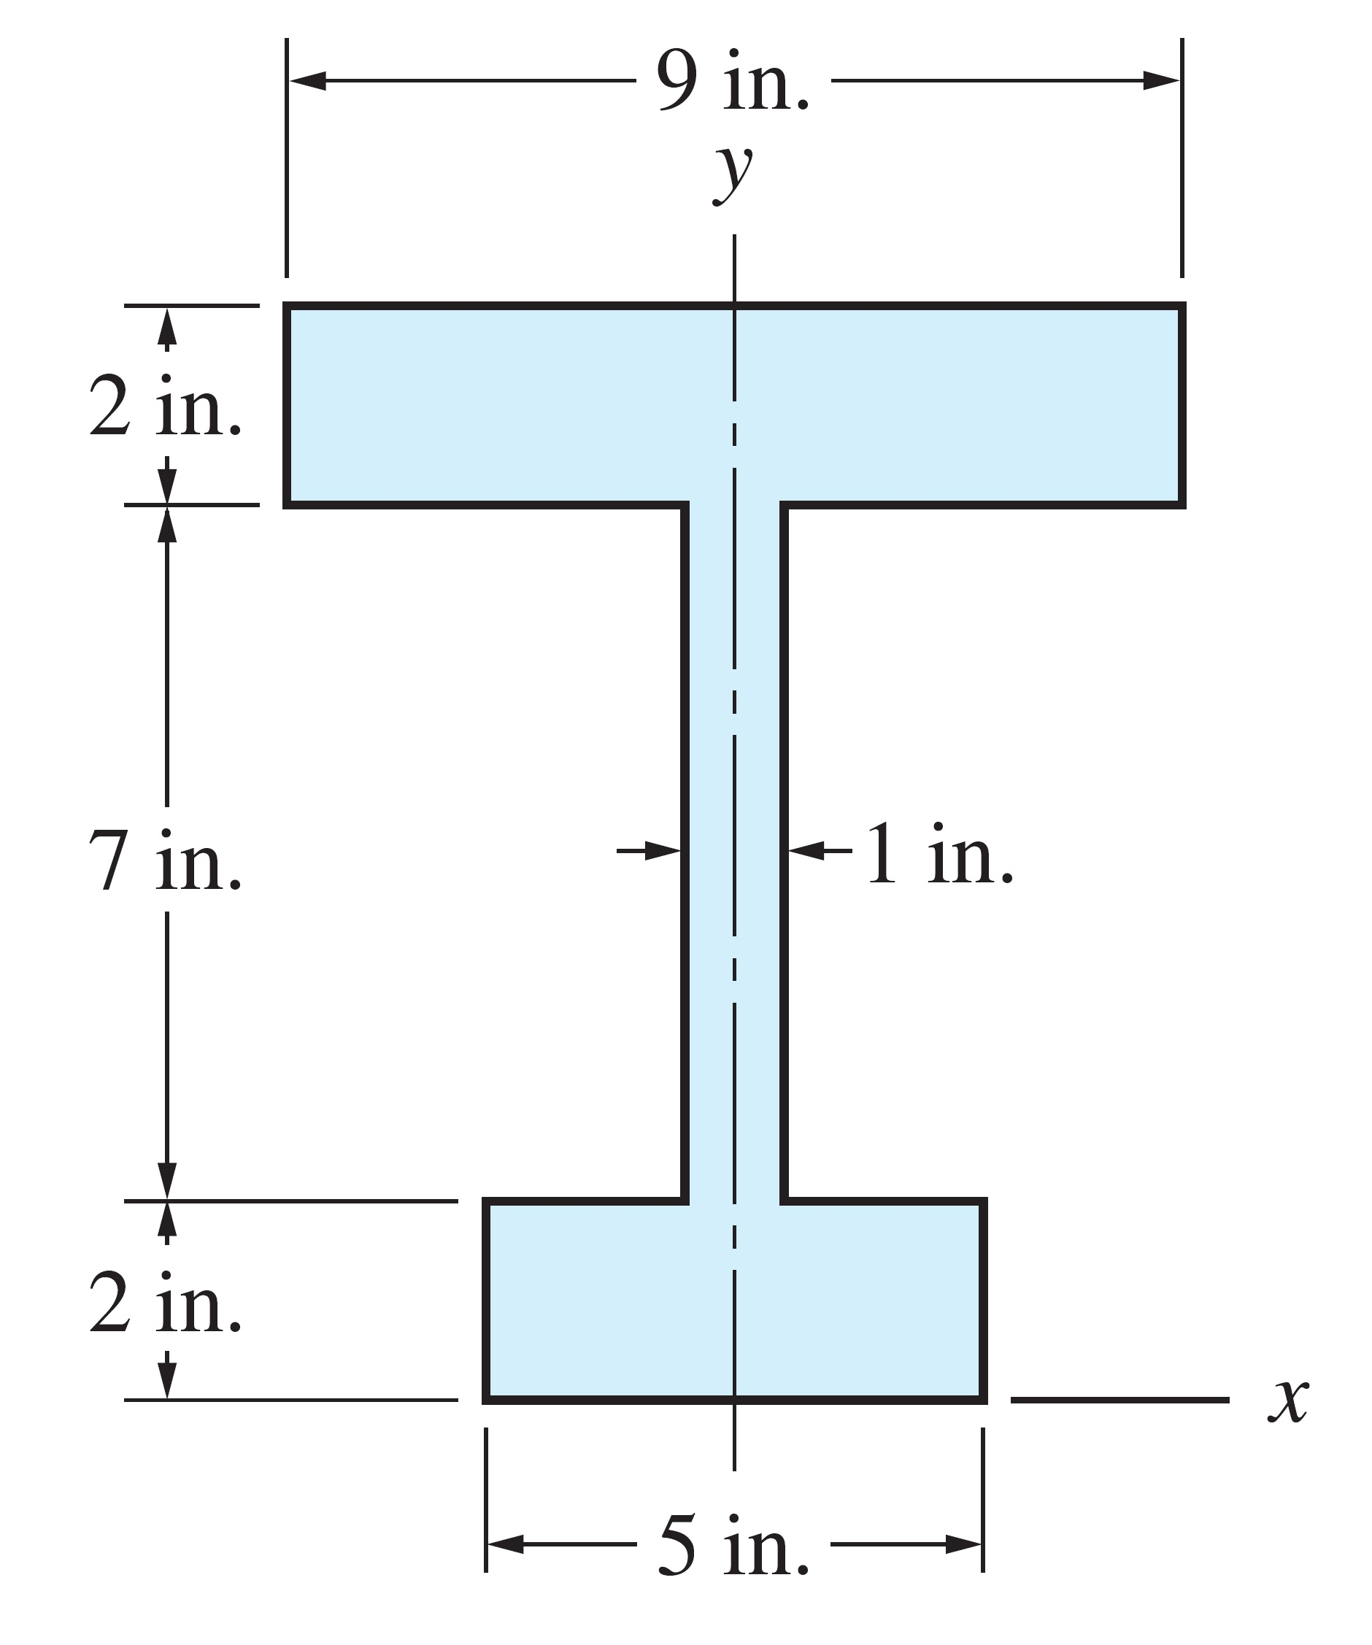
7-4: Figure (a) shows the cross-sectional dimensions for the structural steel section known as C10 × 20 (channel with a nominal depth of 10 in., weighing 20 lb/ft). The American Institute of Steel Construction Structural Steel Handbook lists the following properties for the cross section: and. If two of these channels are welded together as shown in Fig. (b), find I_{x} and I_{y} for the resulting cross section.

