6-1: For the each beam shown, derive the expressions for V and M, and draw the shear force and bending moment diagrams. Neglect the weight of the beam.

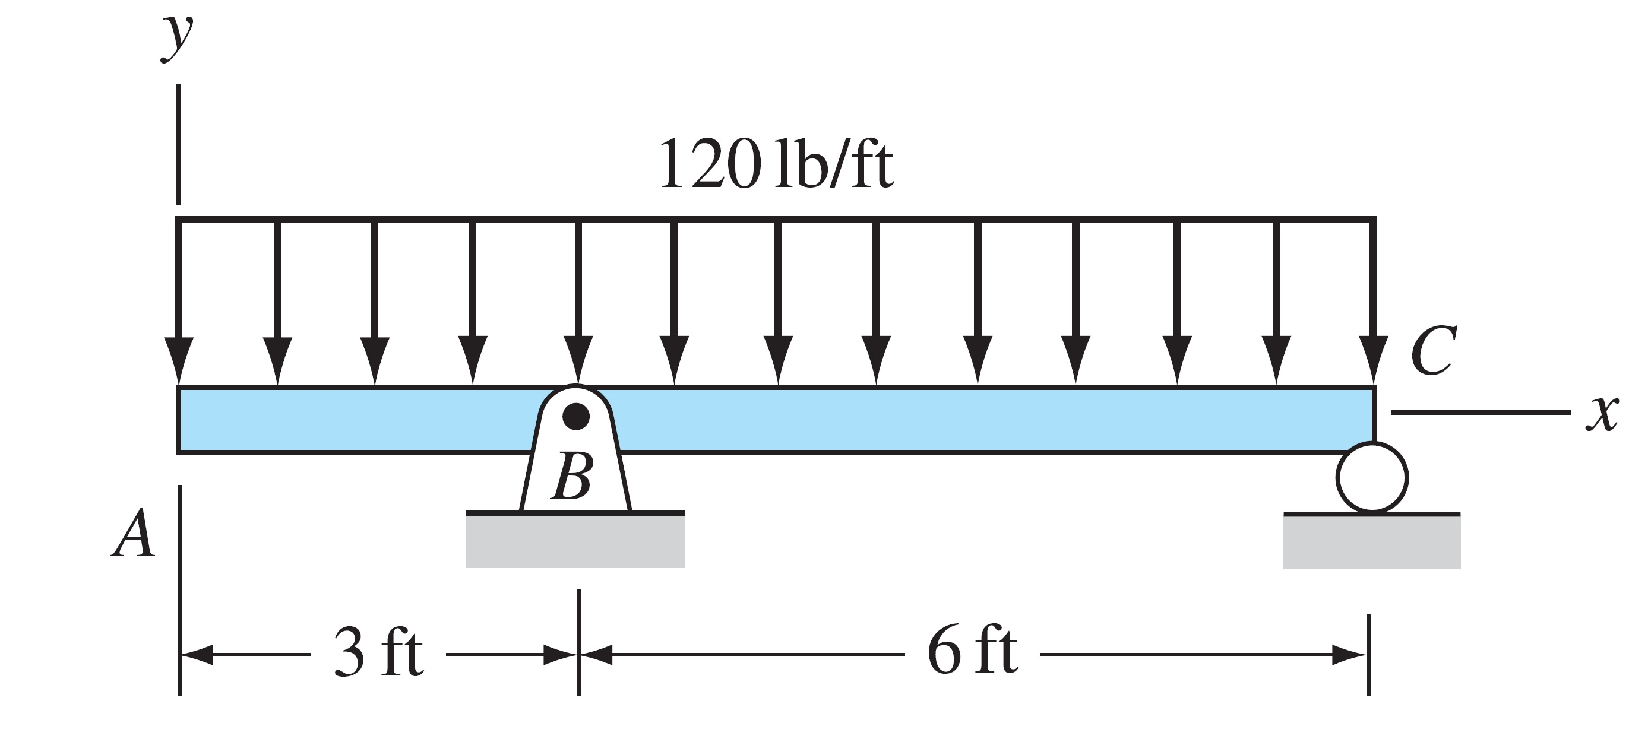

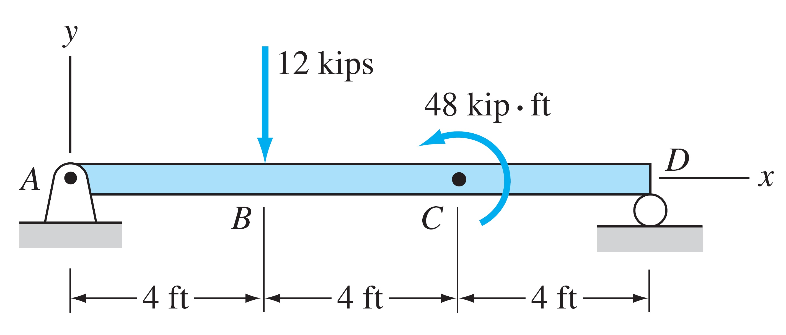

6-2: The beam consists of two segments pin connected at B. Draw the shear and moment diagrams for the beam.

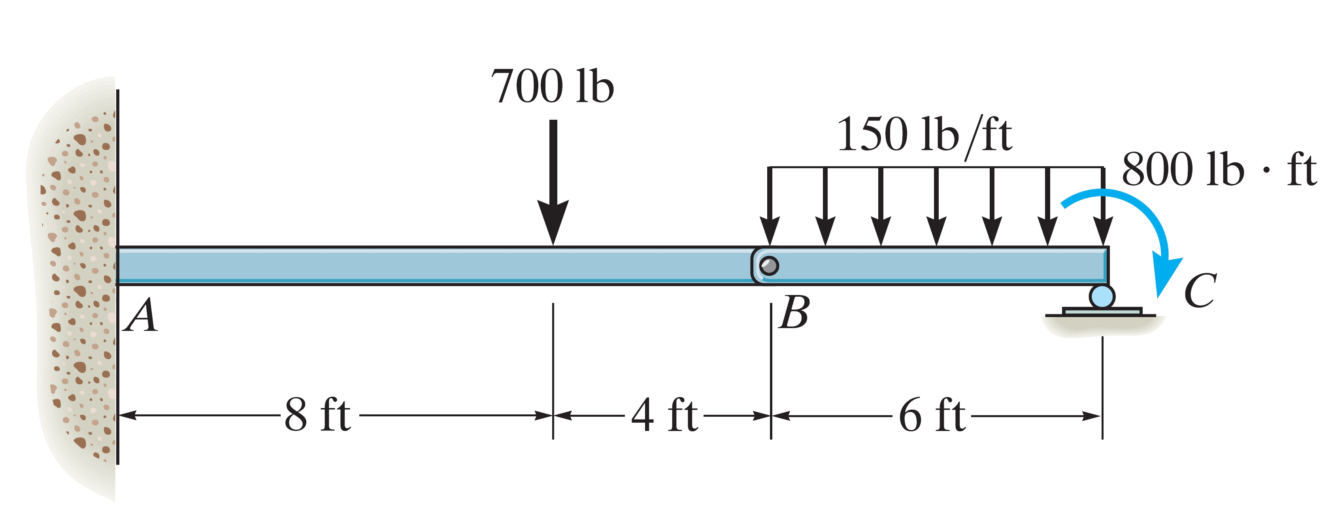
6-3: For the frame and loading shown, determine the support reaction and the components of the forces acting at B, C, and F.

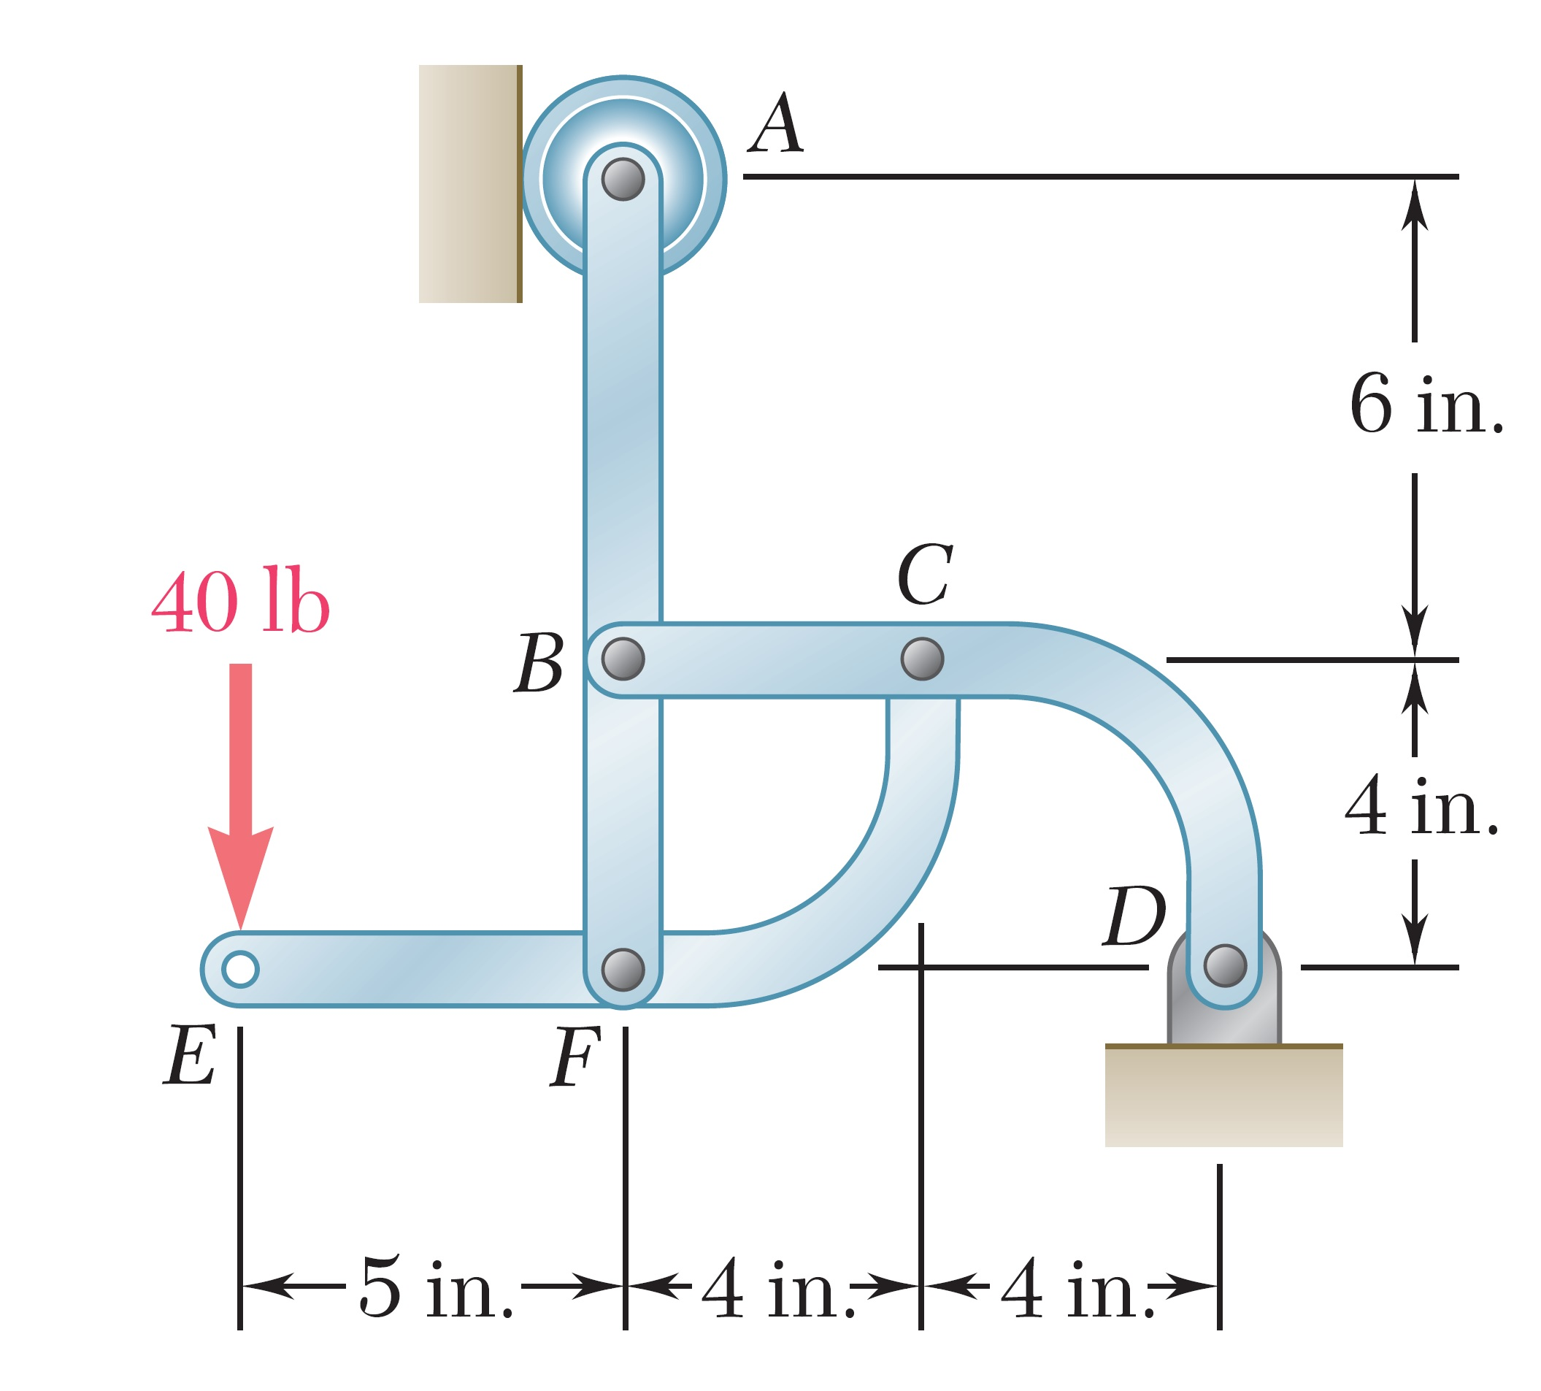
6-4: For the frame and loading shown, determine the support reaction and the components of the forces acting at B, C, and E.

