5-1: Determine the displacement of joints and the force in each members. Take , .

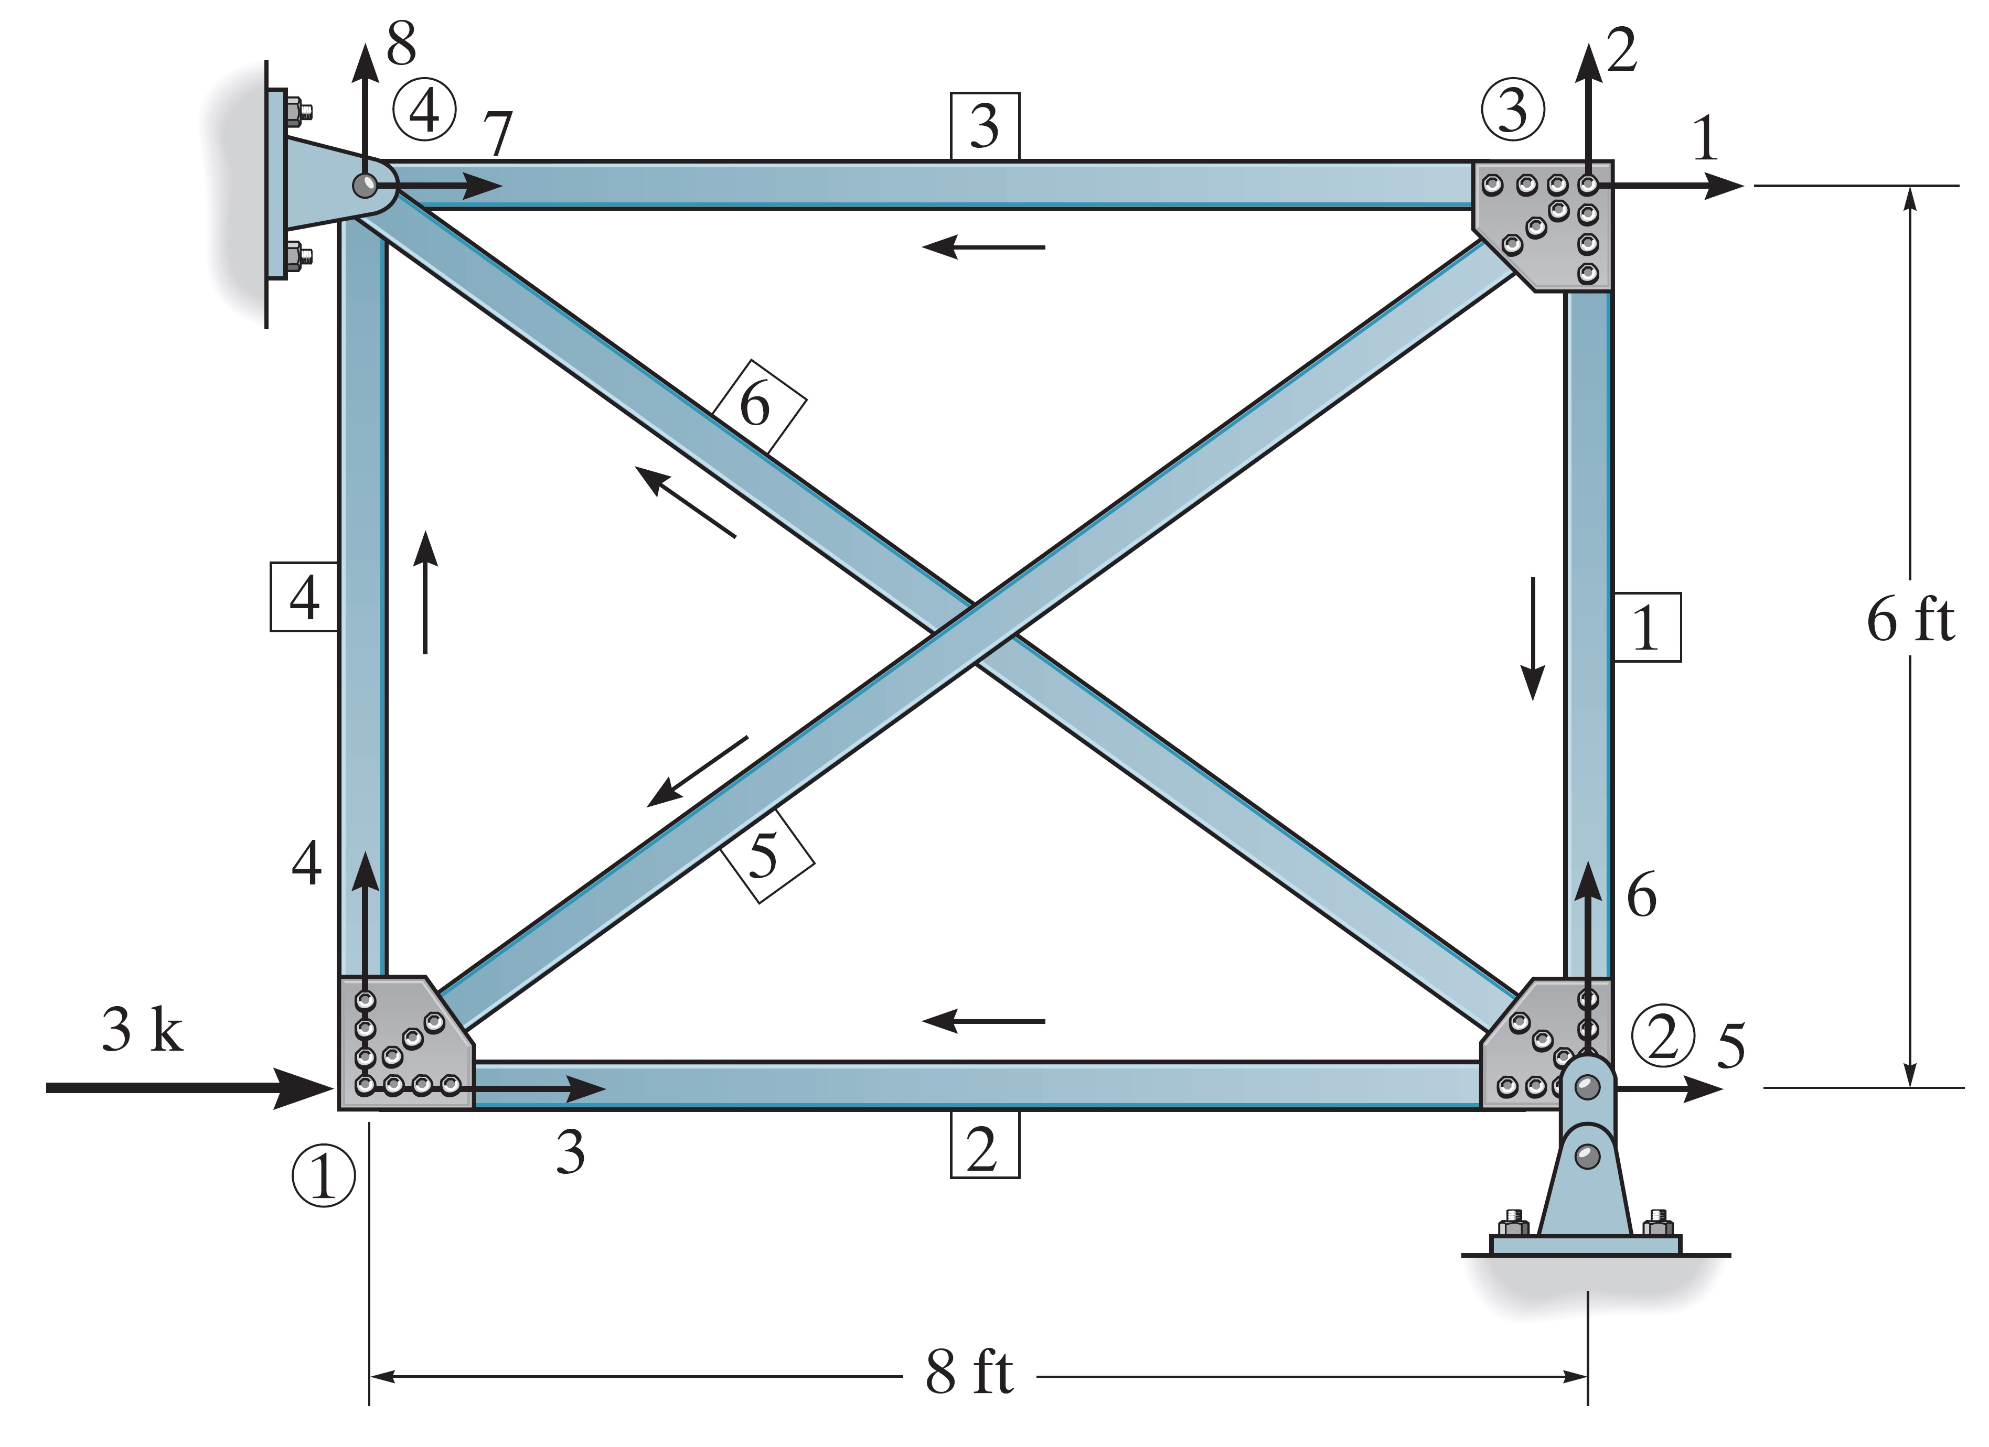

5-2: Determine the joint displacements and the support reactions. EI is constant.

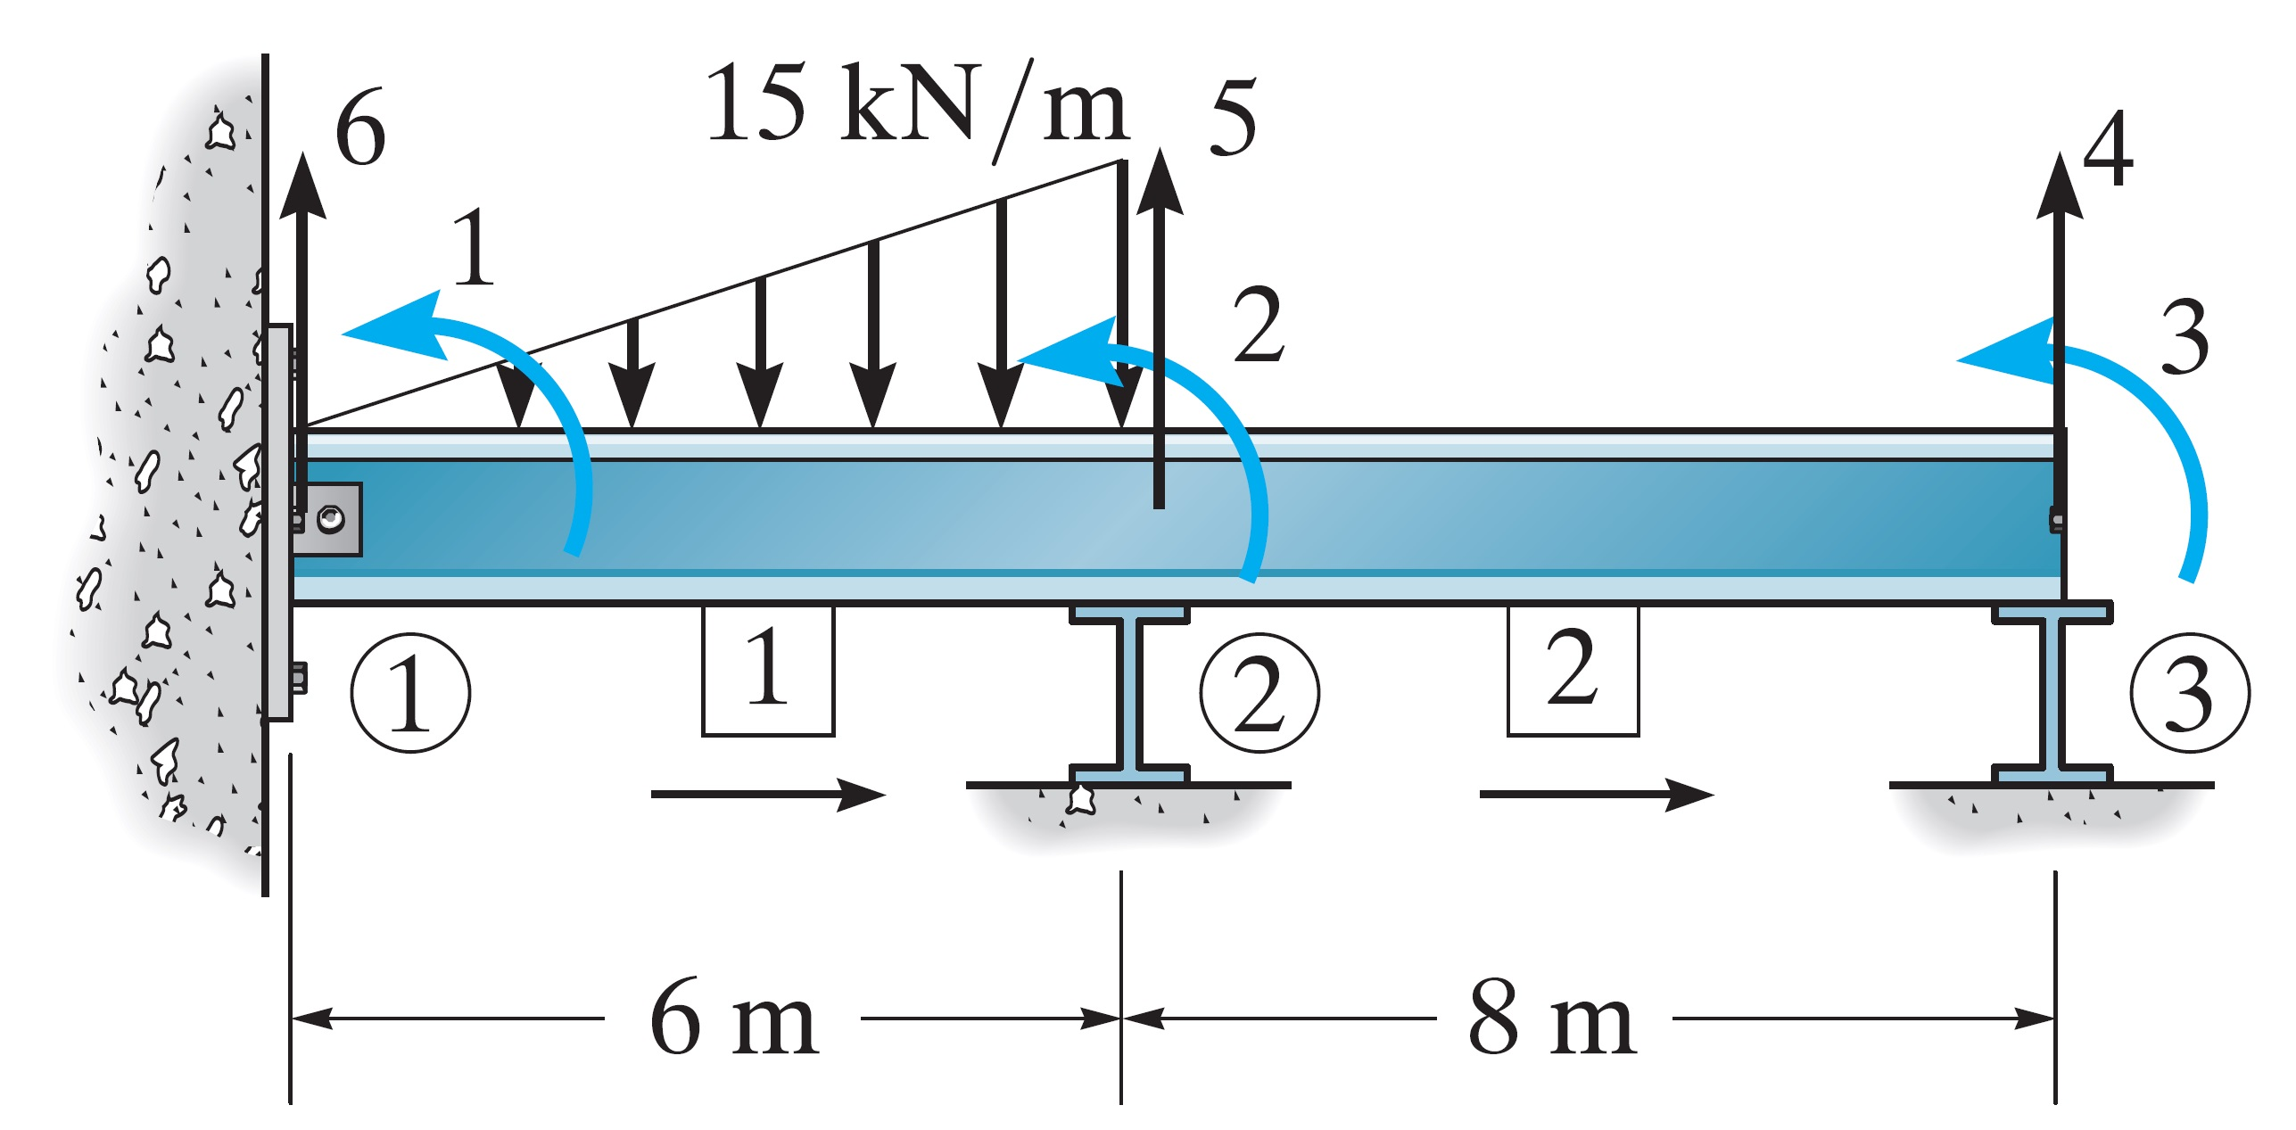

5-3: Determine the joint displacements and the support reactions. Assume joint 1 and 3 are fixed. Take , , for each member.



