5-1: Determine the coordinates of the centroid of the area that lies between the straight line and the parabola, where x and y are measured in inches. Use the following methods: (1) double integration; (2) single integration using a horizontal differential area element; and (3) single integration using a vertical differential area element.

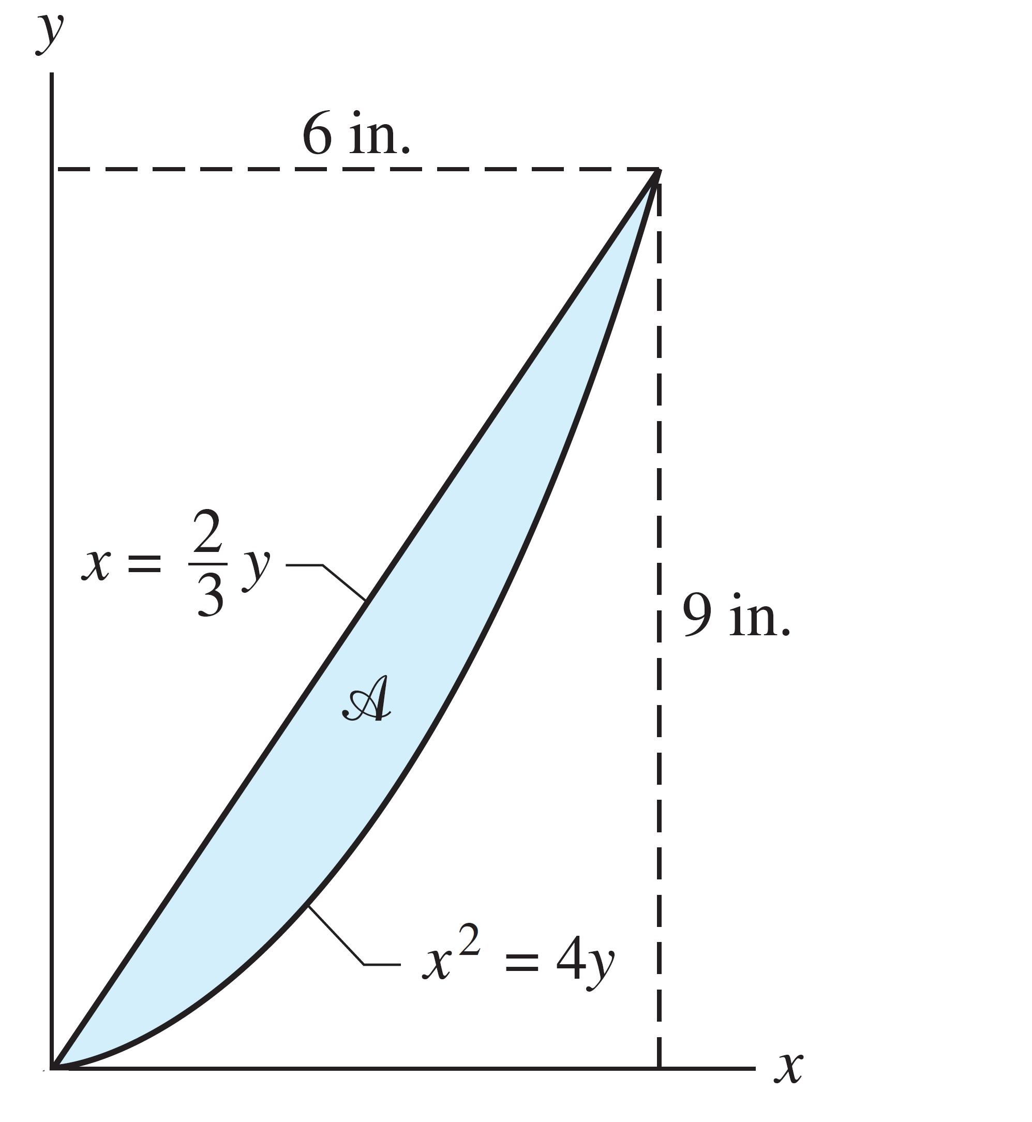

5-2: Using the method of composite areas, determine the location of the centroid of the shaded area shown in Figure.

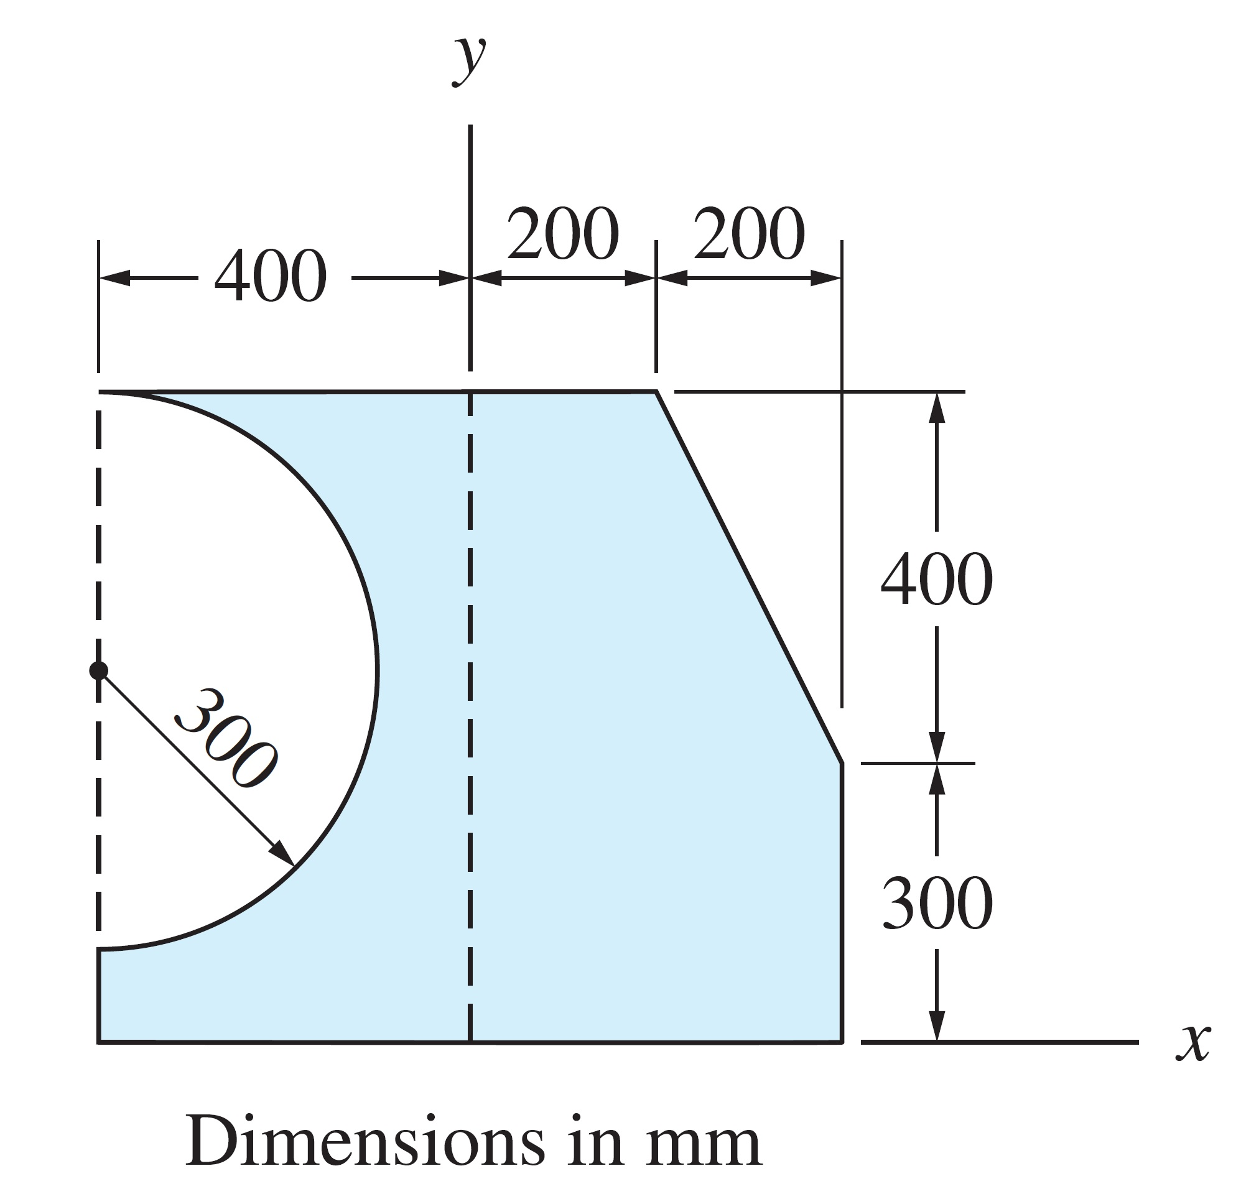

5-3: Using the method of composite curves, determine the centroidal coordinates of the line in Figure that consists of the circular arc 1, and the straight lines 2 and 3.

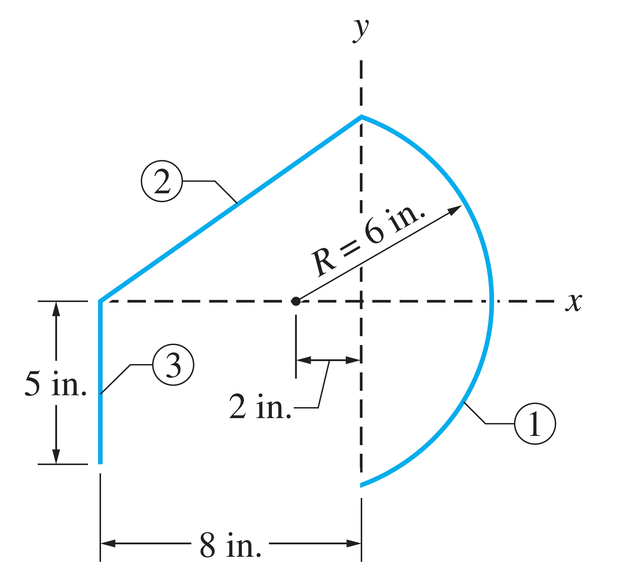

5-4: By the method of composite volumes, determine the centroidal coordinates of the volume.

