1-1: (a) The magnitudes of the two velocity vectors are v₁ = 3 m/s and v₂ = 2 m/s. Determine their resultant v = v₁ + v₂.

(b) Determine the magnitudes of vectors v₁ and v₂ so that their resultant is a horizontal vector of magnitude 4 m/s directed to the right.

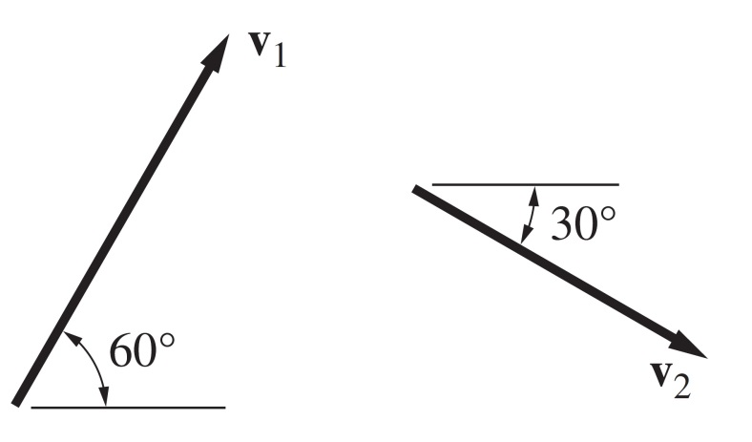

1-2: The 500-N weight is supported by two cables, the cable forces being F₁ and F₂. Knowing that the resultant of F₁ and F₂ is a force of magnitude 500N acting in the y-direction, determine F₁ and F₂.
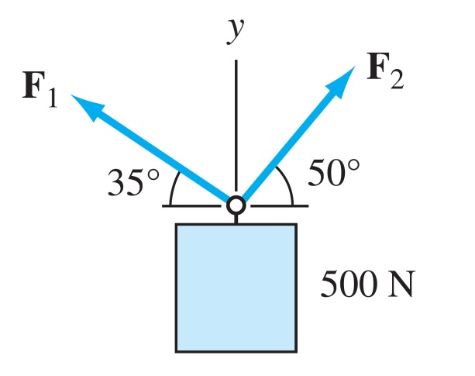

1-3: Given the vectors
A = 9i + 4j − 3k lb
B = 3j + 6k ft
C = 3i − 2j + 5k ft
Calculate the following: (1) A·B; (2) the angle between A and C; (3) A × B; (4) the angle between C and z axes; and (5) (A × B) ·C.

1-4: Determine the angle between of cables AD and AC.
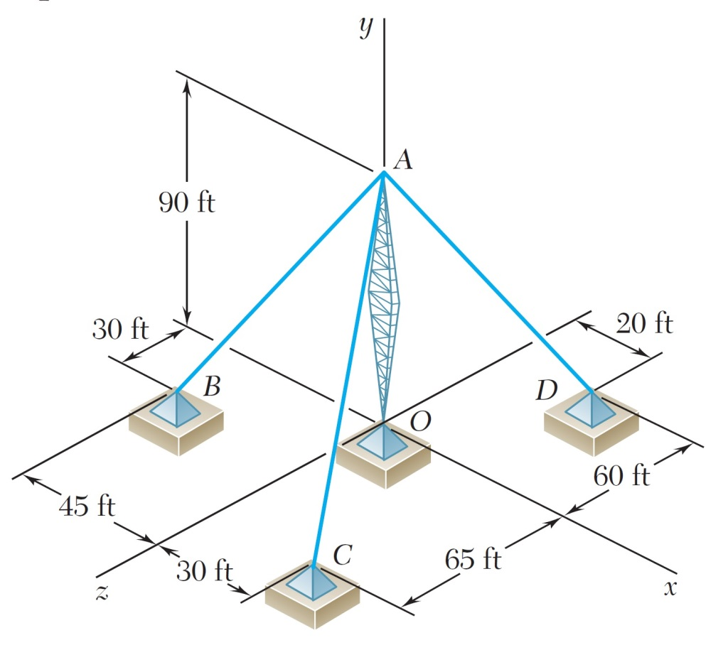

1-5: Two forces are applied at point B of beam AB. Determine the magnitude and direction of their resultant using the triangle rule.

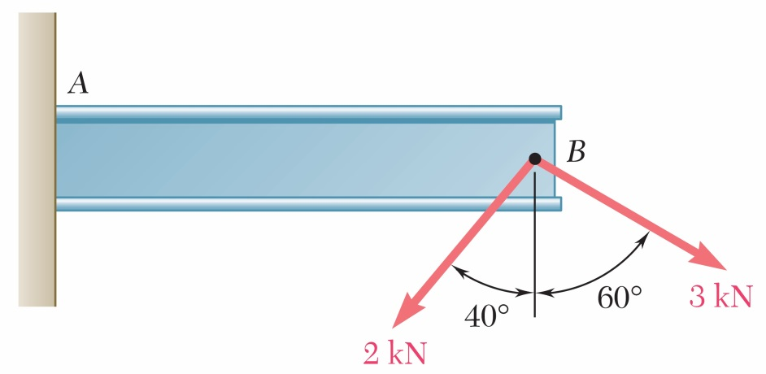

1-6: Determine the x and y components of each of the forces shown.
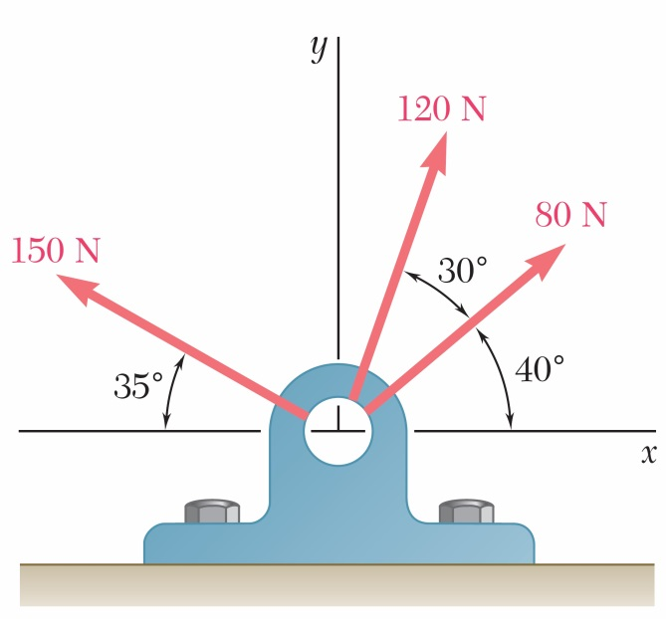
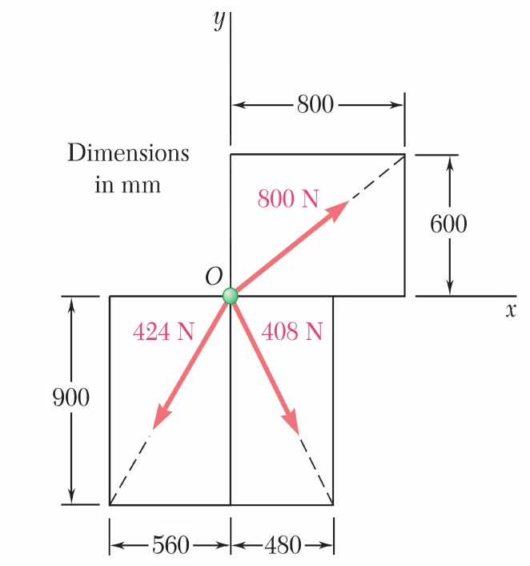

1-6: Determine the angle α so that resultant of three forces shown in figure is a vertical force.

