3-1: Determine the horizontal and vertical components of reaction at the supports. Neglect the thickness of the beam.
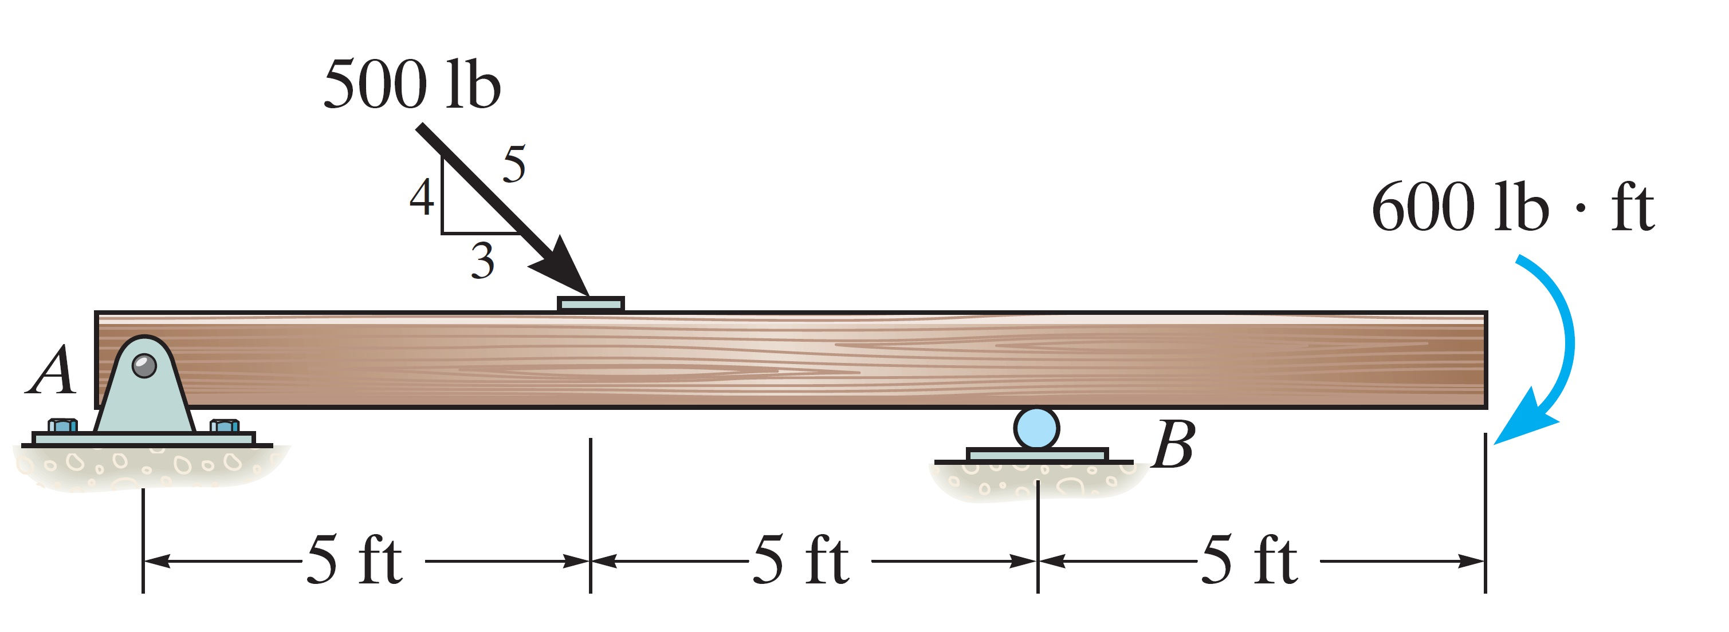

3-2: The truss is supported by a pin at A and a roller at B. Determine the support reactions.
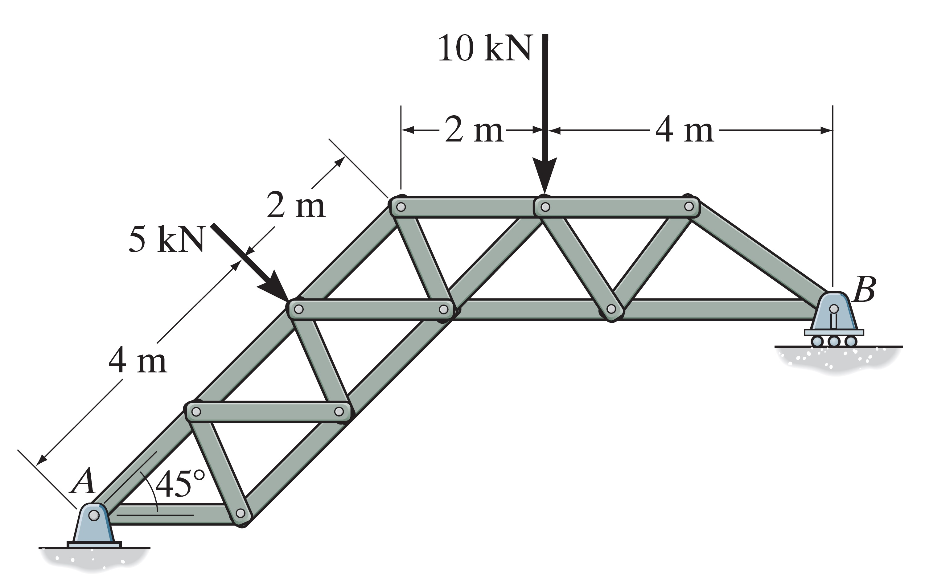

3-3: Determine the horizontal and vertical components of reaction at the pin A and the tension developed in cable BC used to support the steel frame.

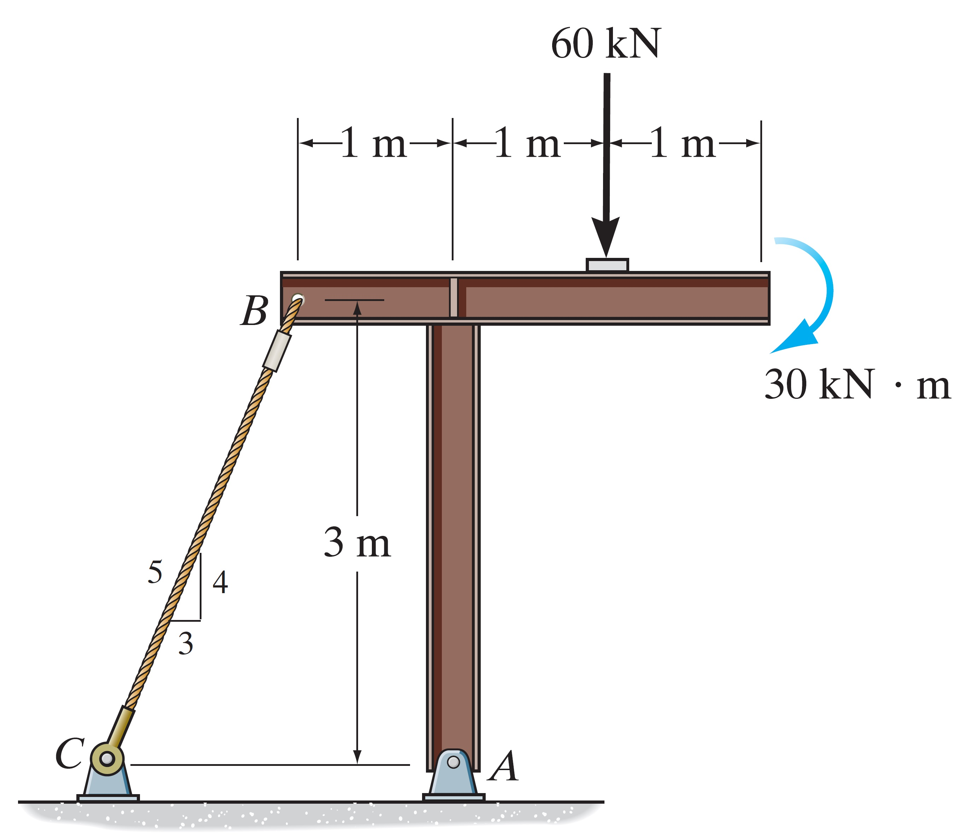
3-4: Determine the horizontal and vertical components of force at the pin A and the reaction at the roller B of the curved beam.

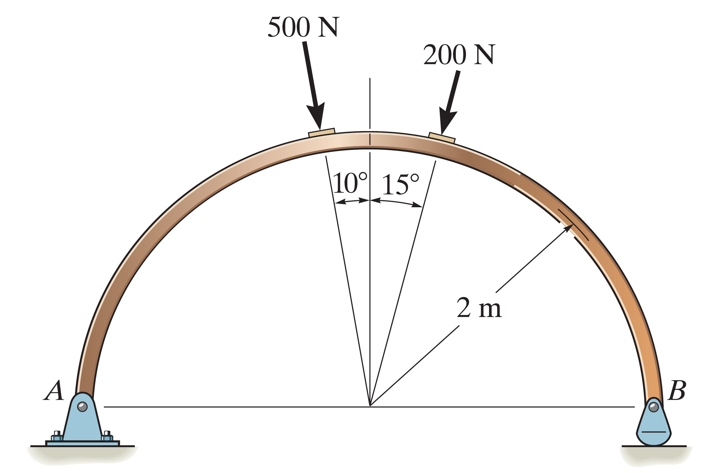

3-5: The boom is used to support the 75-lb flowerpot shown in Figure. Determine the tension developed in wires AB and AC and then determine the reaction components of the ball-and-socket joint at A.

