2-1: For each case illustrated in figure (1) determine the moment of the forces about point O.

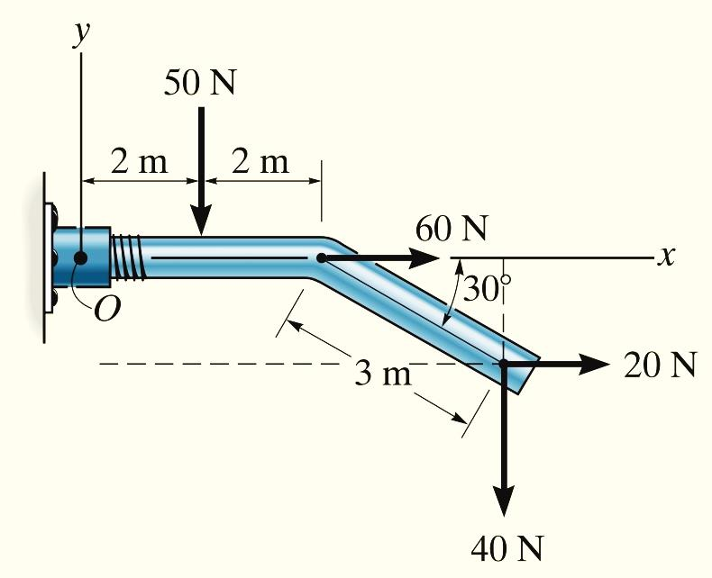
(a)

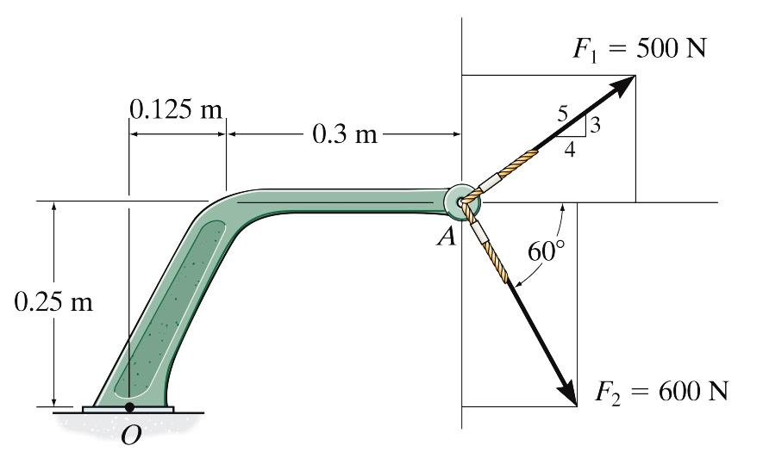
(b)

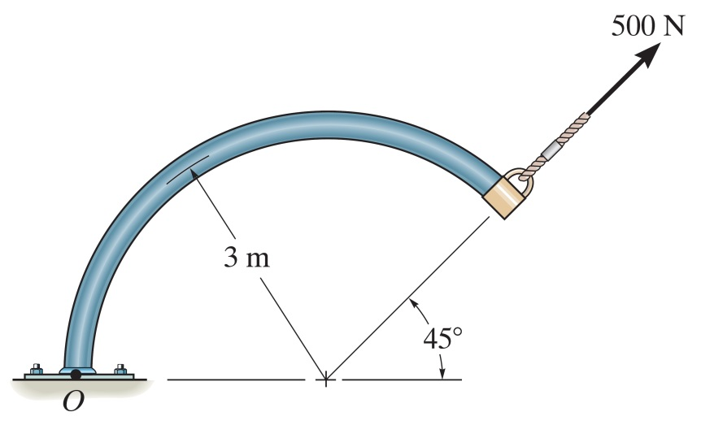
(c)
Figure (1)
2-2: If the man at B exerts a force of P = 30 lb on his rope, determine the magnitude of the force F the man at C must exert to prevent the pole from rotating, i.e., so the resultant moment about A of both forces is zero.

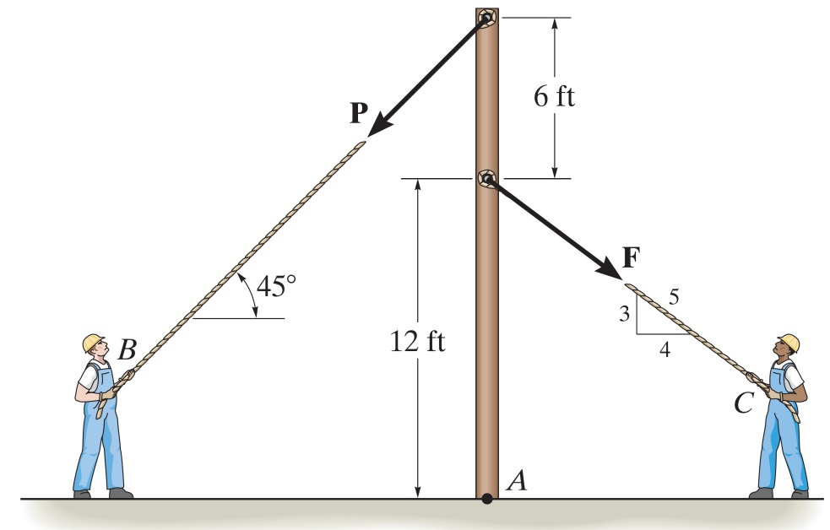

2-3: Determine the resultant moment produced by forces F_{B} and F_{C} about point O. Express the result as a Cartesian vector.

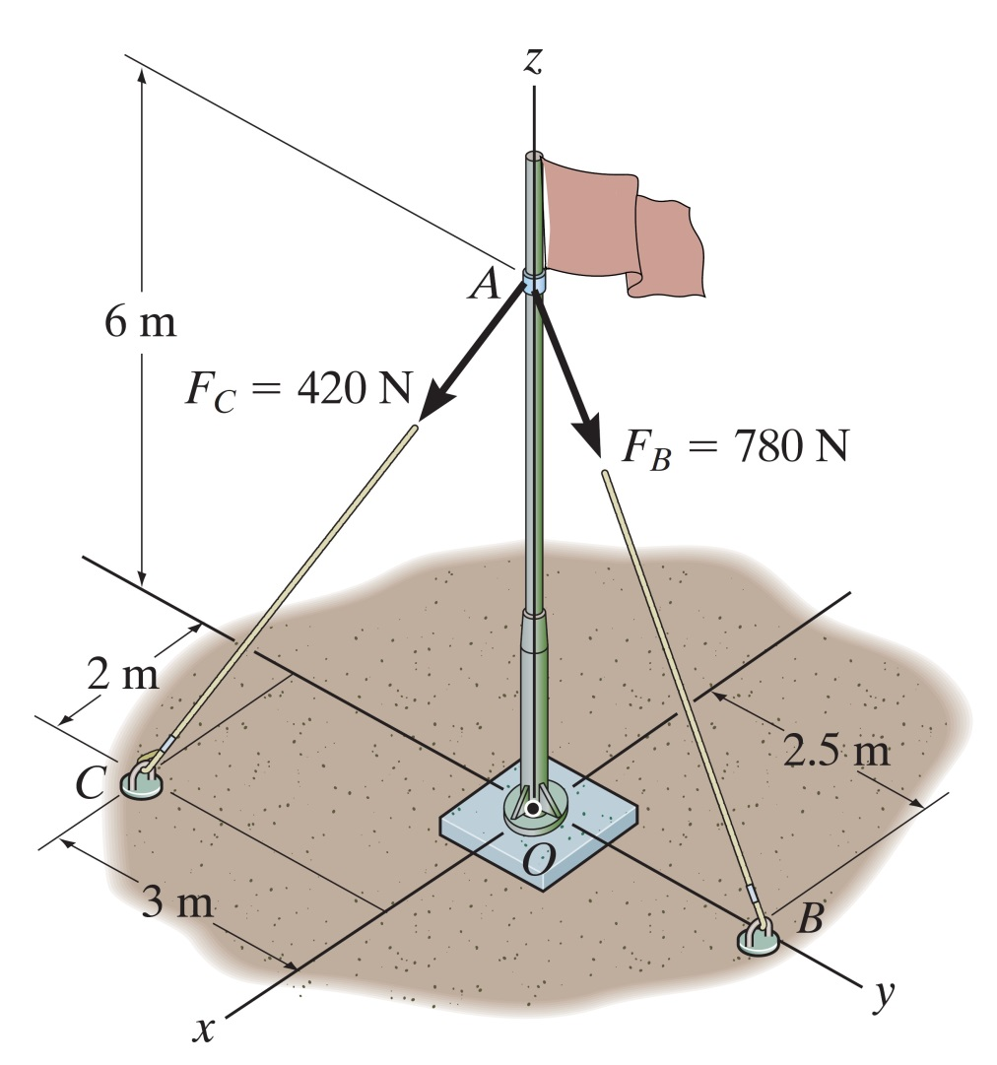
2-4: Determine the required magnitude of force F so that the resultant couple moment on the frame is 200 lb. ft, clockwise.

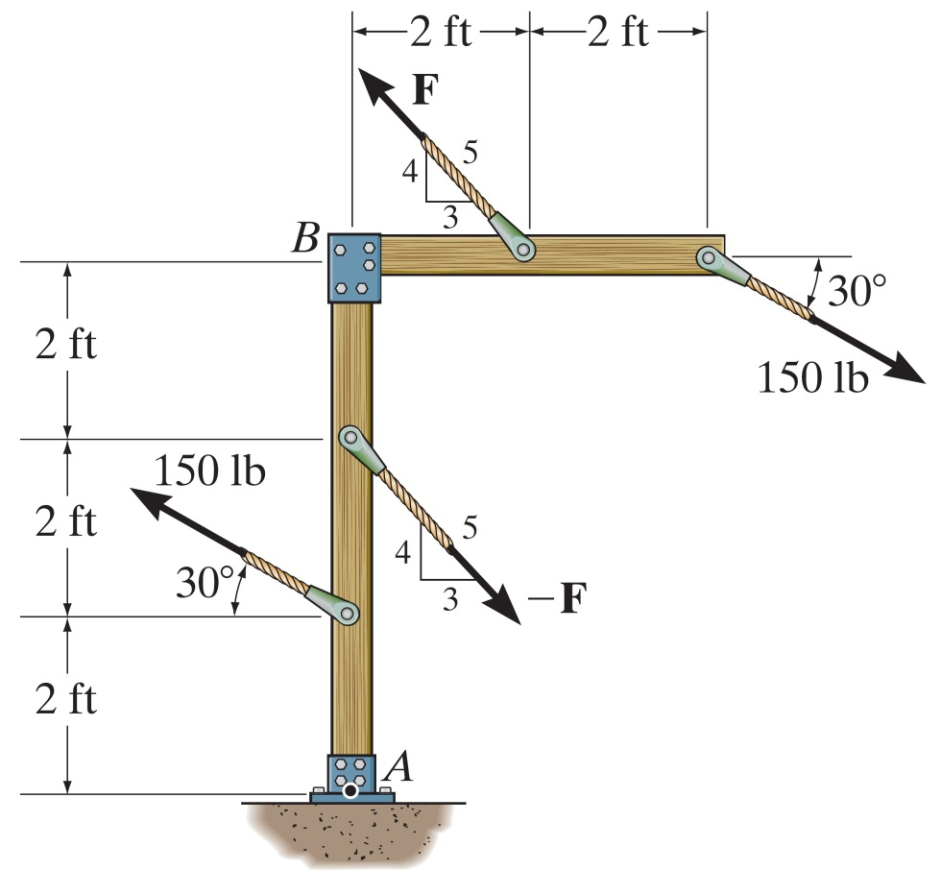

2-5: Replace the force and couple system shown in figure by an equivalent resultant force and couple moment acting at point O.

